**Introduction to Amazon EC2**

## Accessing the AWS Management Console

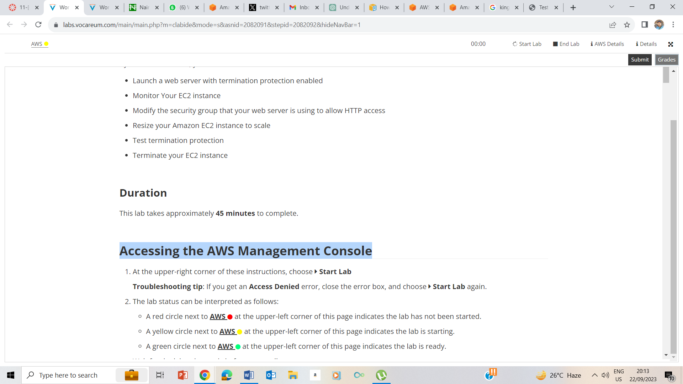

1. Start Lab. – The Lab is loading

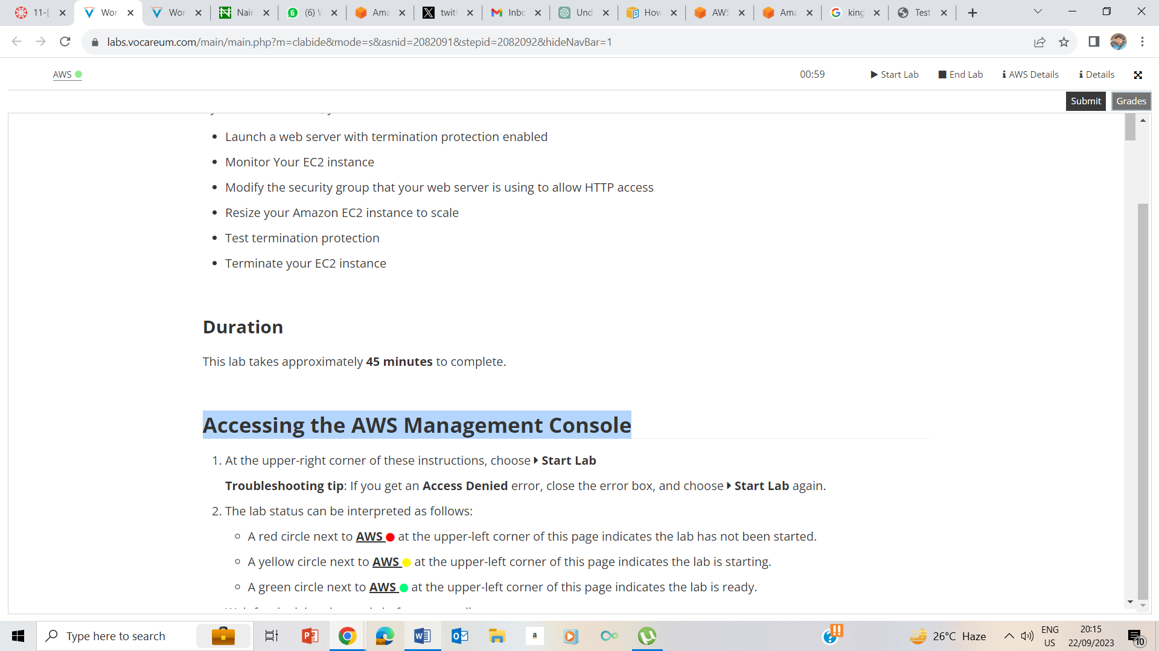

The Lab is ready

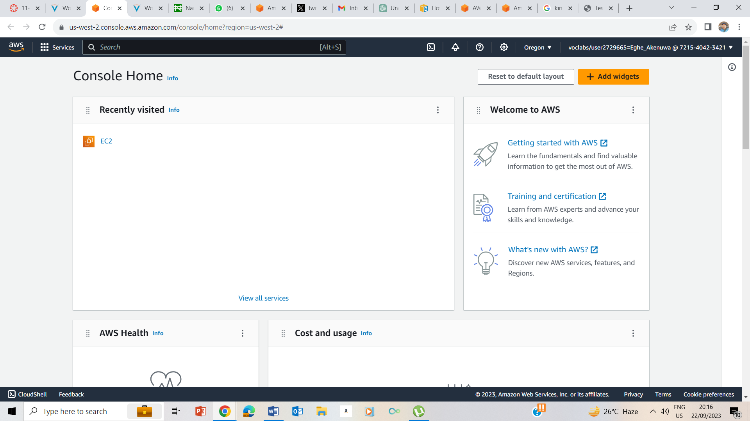

I clicked on the AWS green button to take me to the AWS Management console in a new page.

## Task 1: Launching your EC2 instance

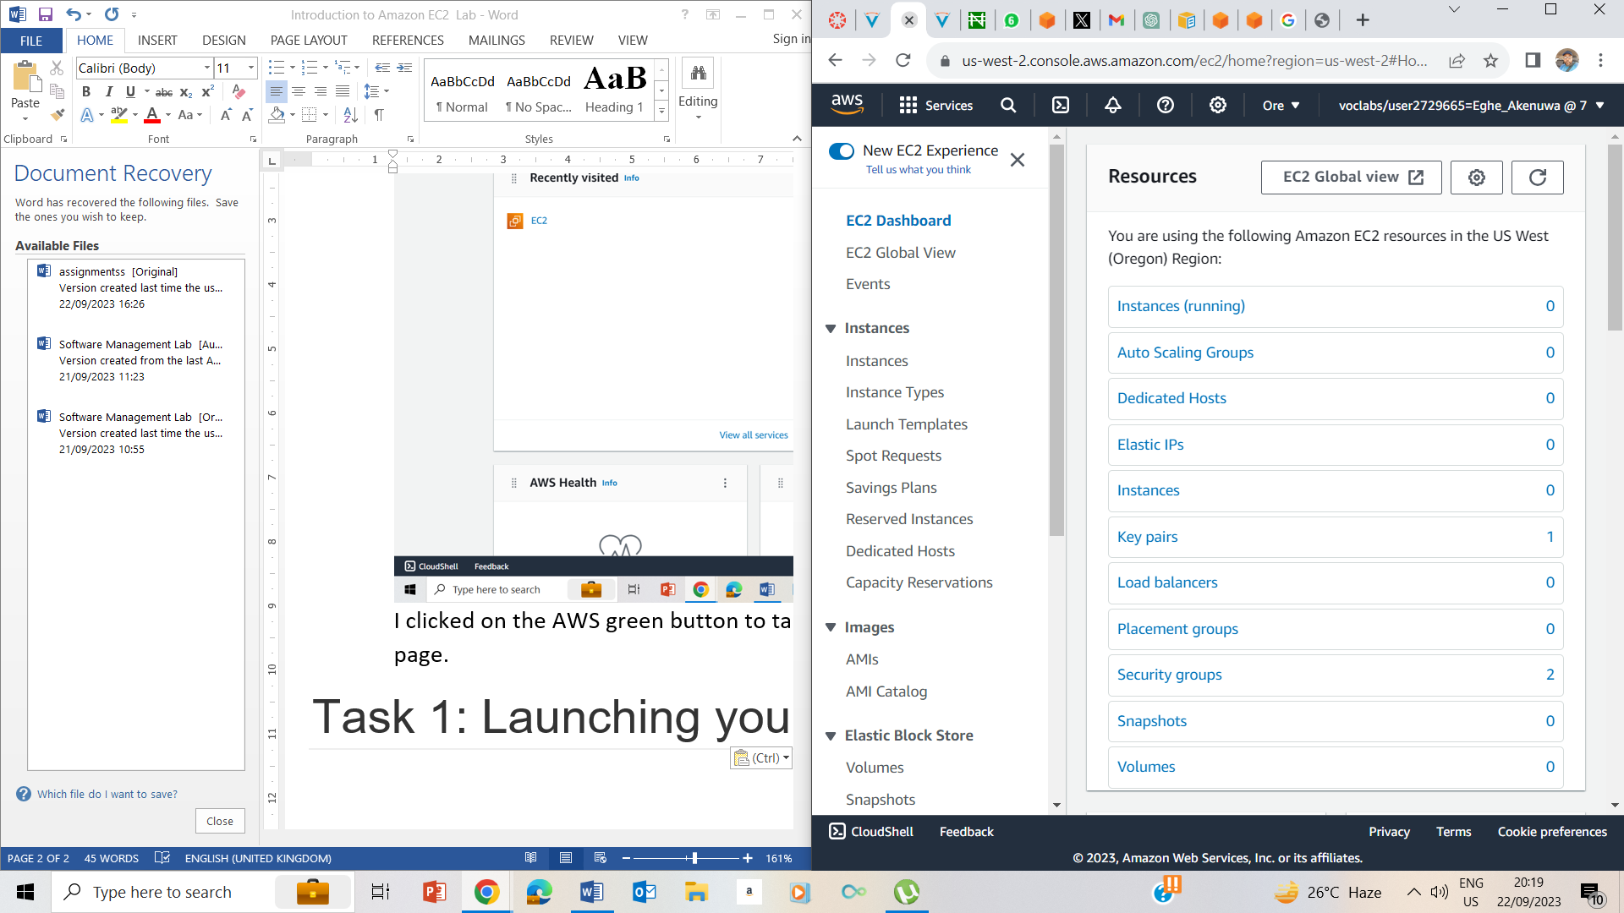

On the services meny, I choosed EC2,

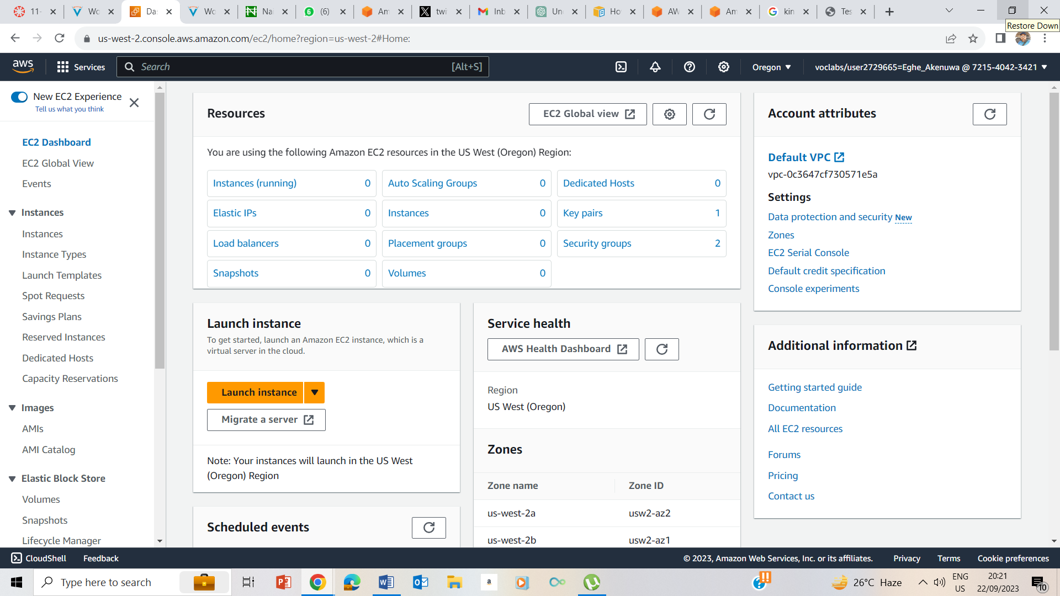

Clicked on EC2 Dashboard, and clicked on Launch Instance.

### Step 1: Naming your EC2 instance

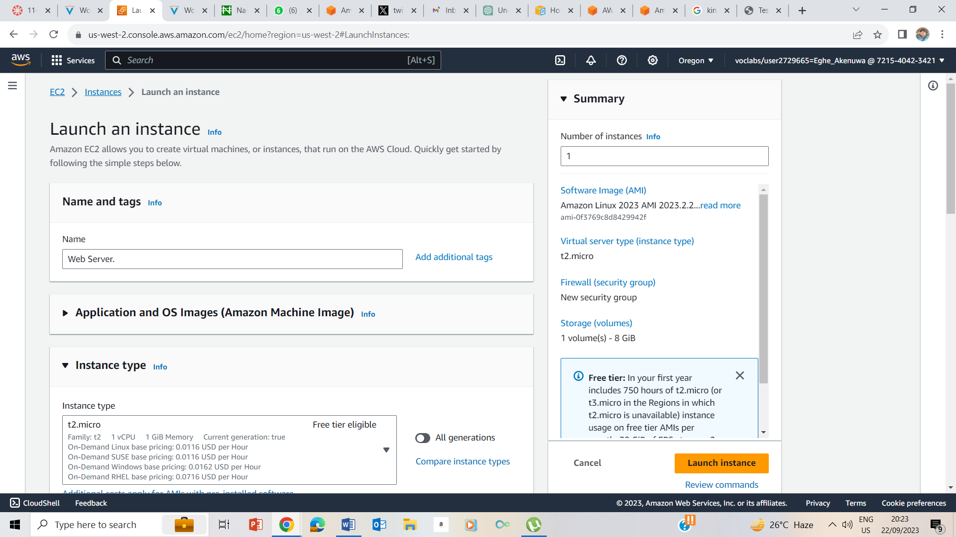

Change the name to web server

### Step 2: Choosing an Amazon Machine Image (AMI)

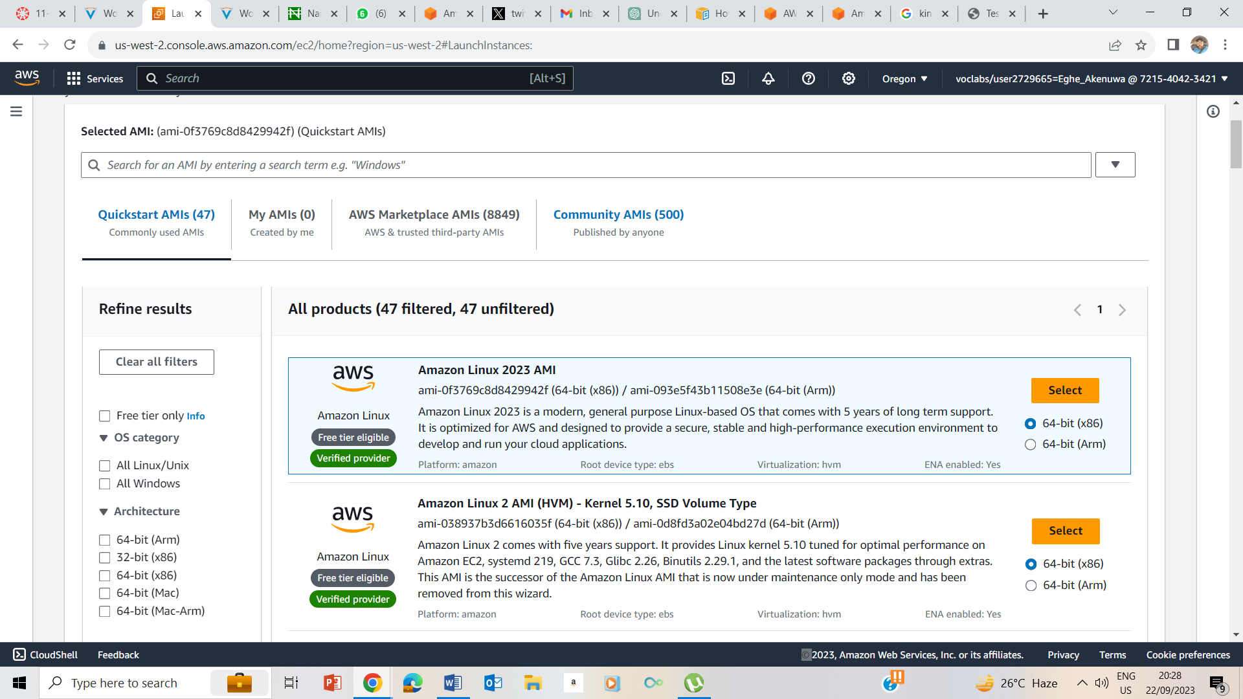

10. Under the AMI , the Amazon Linux2 AMI is chosen by default and is left that way.

### Step 3: Choosing an instance type

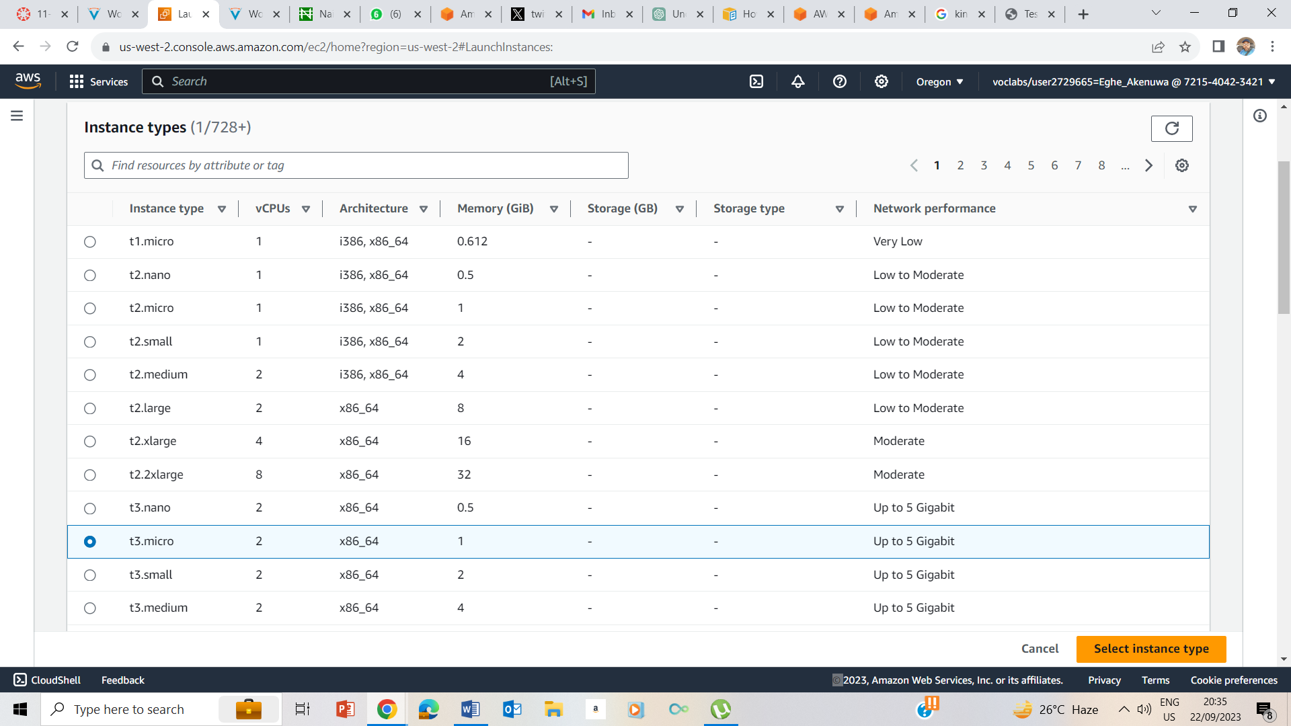

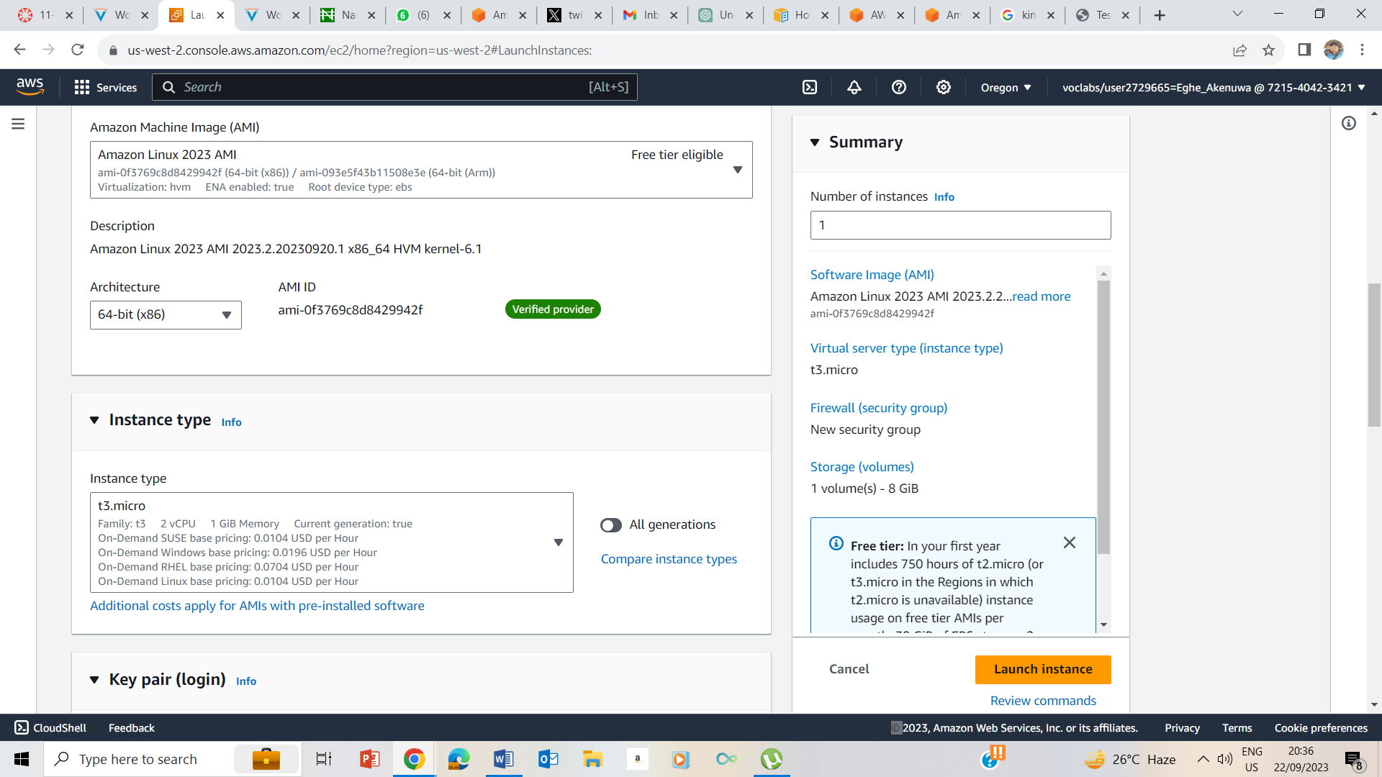

11. Selected t3.micro instance

### Step 4: Configuring a key pair

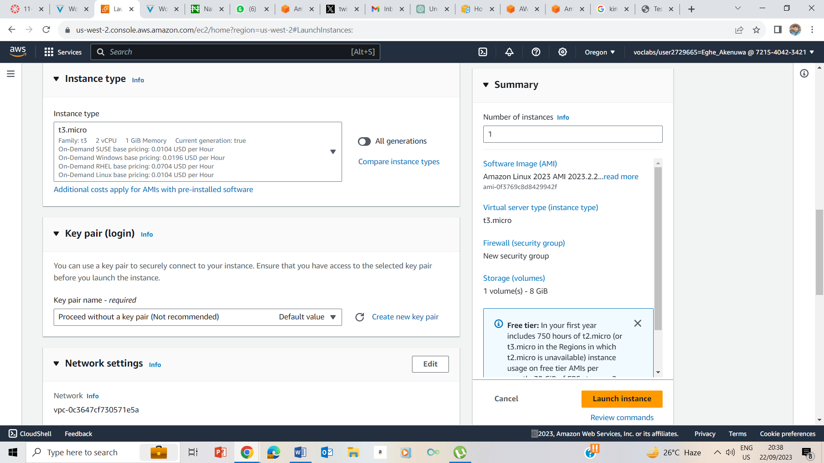

12. In the key pair (log in), I choose proceed without a keypair (Not recommended)

### Step 5: Configuring the network settings

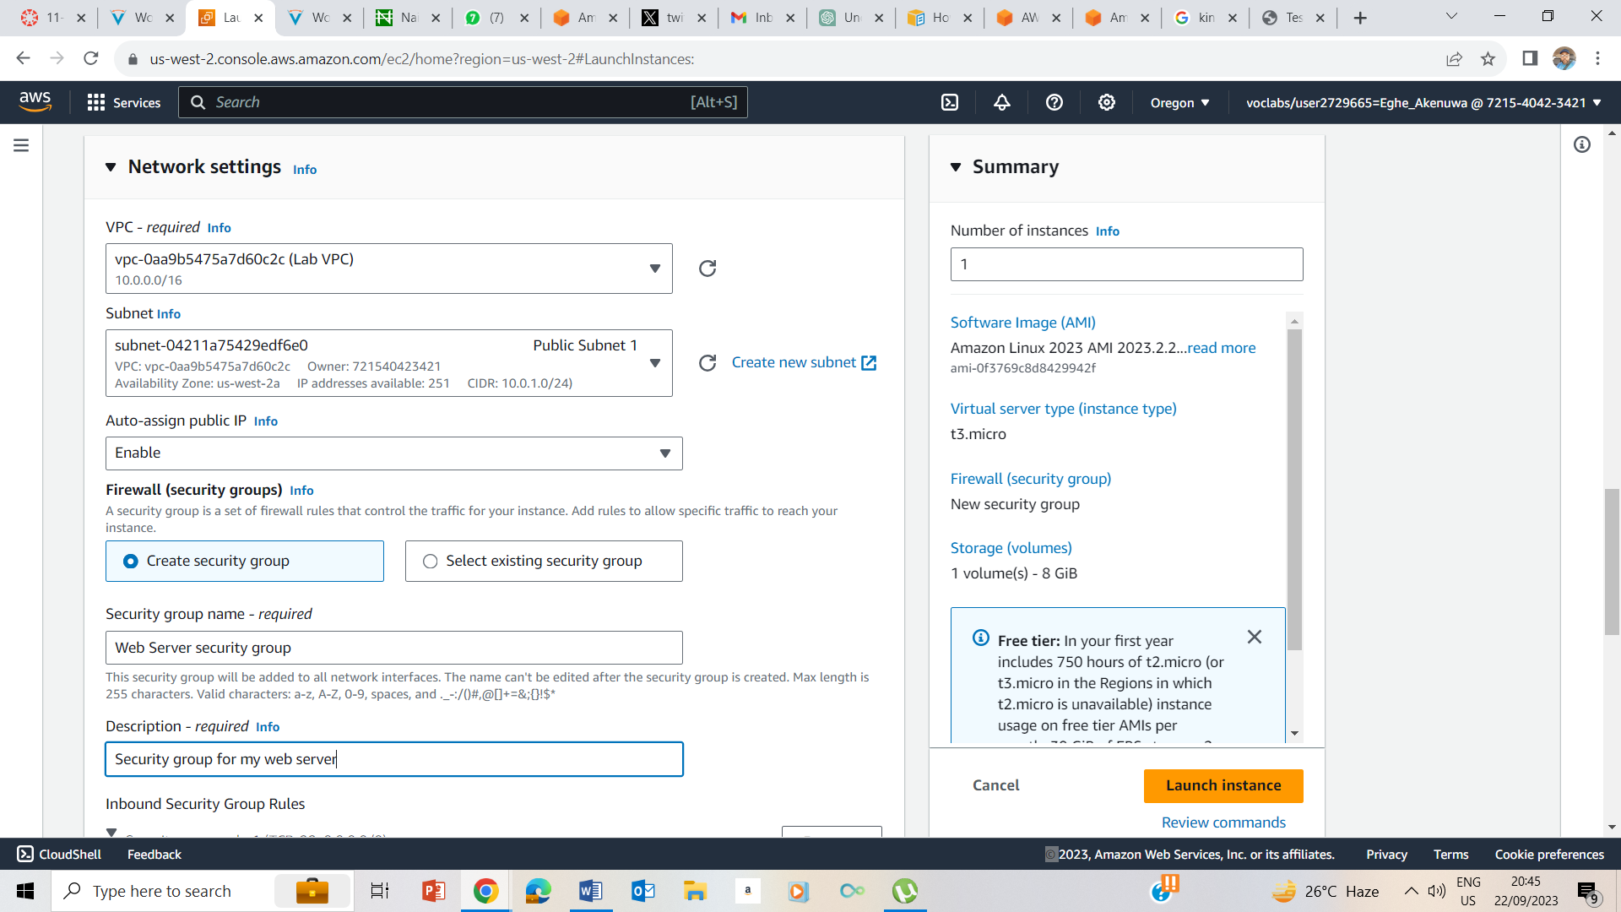

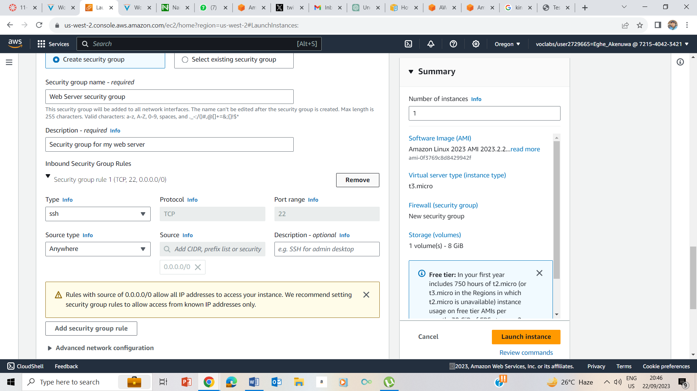

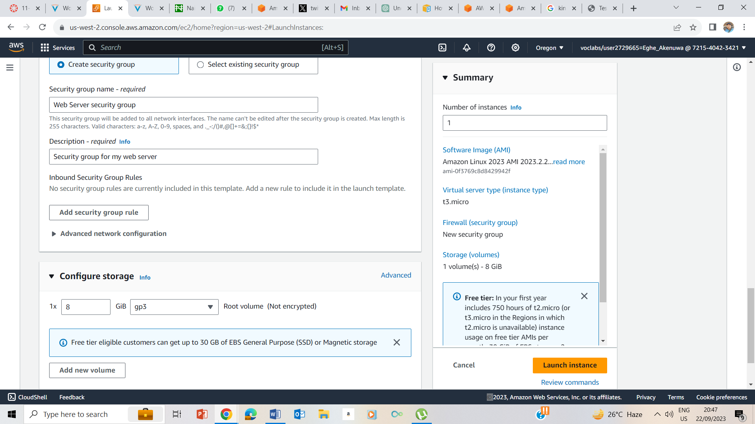

In the inbound security rules, I chose Remove

### Step 6: Adding storage

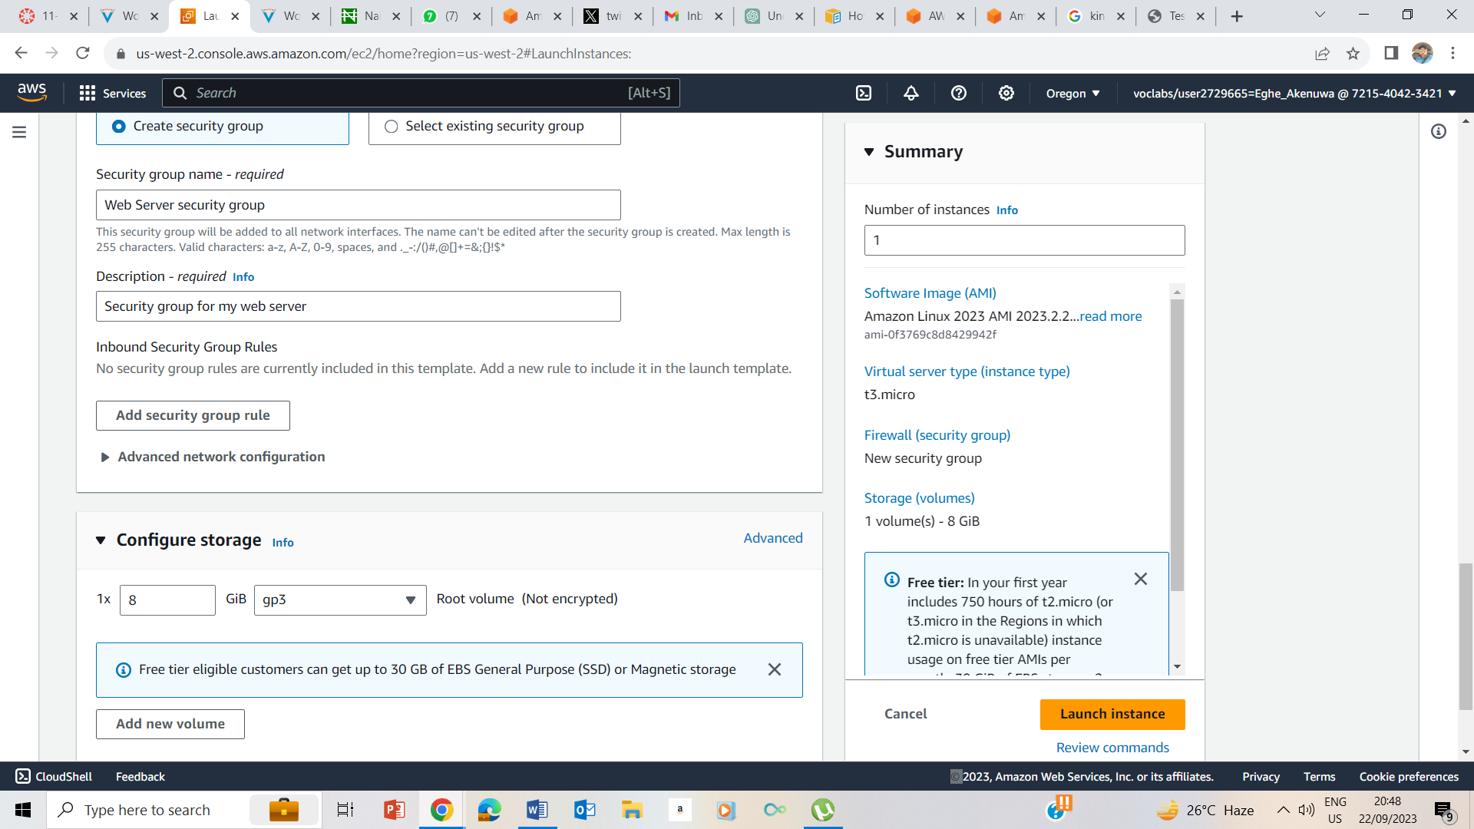

In the Configure Storage, I kept the default storage

### Step 7: Configuring advanced details

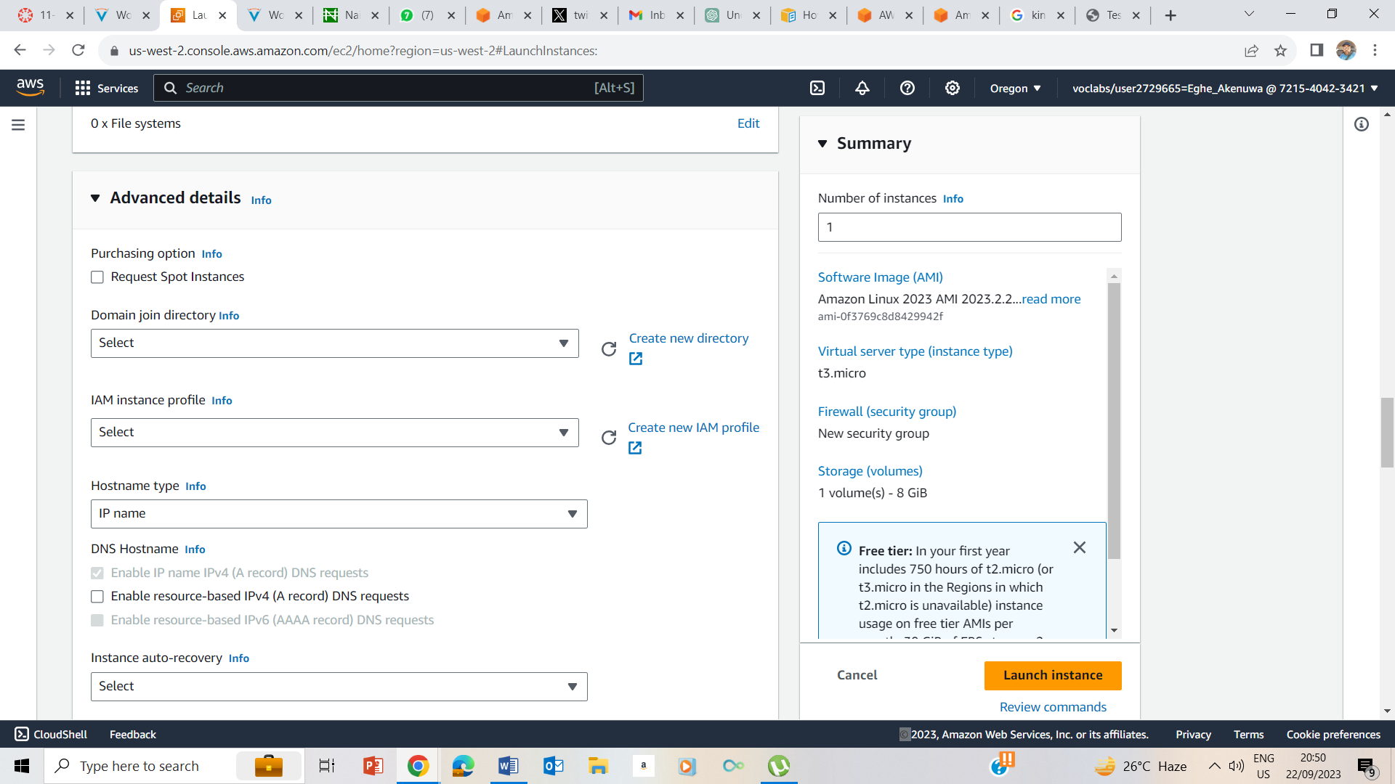

I Expanded the Advanced Details

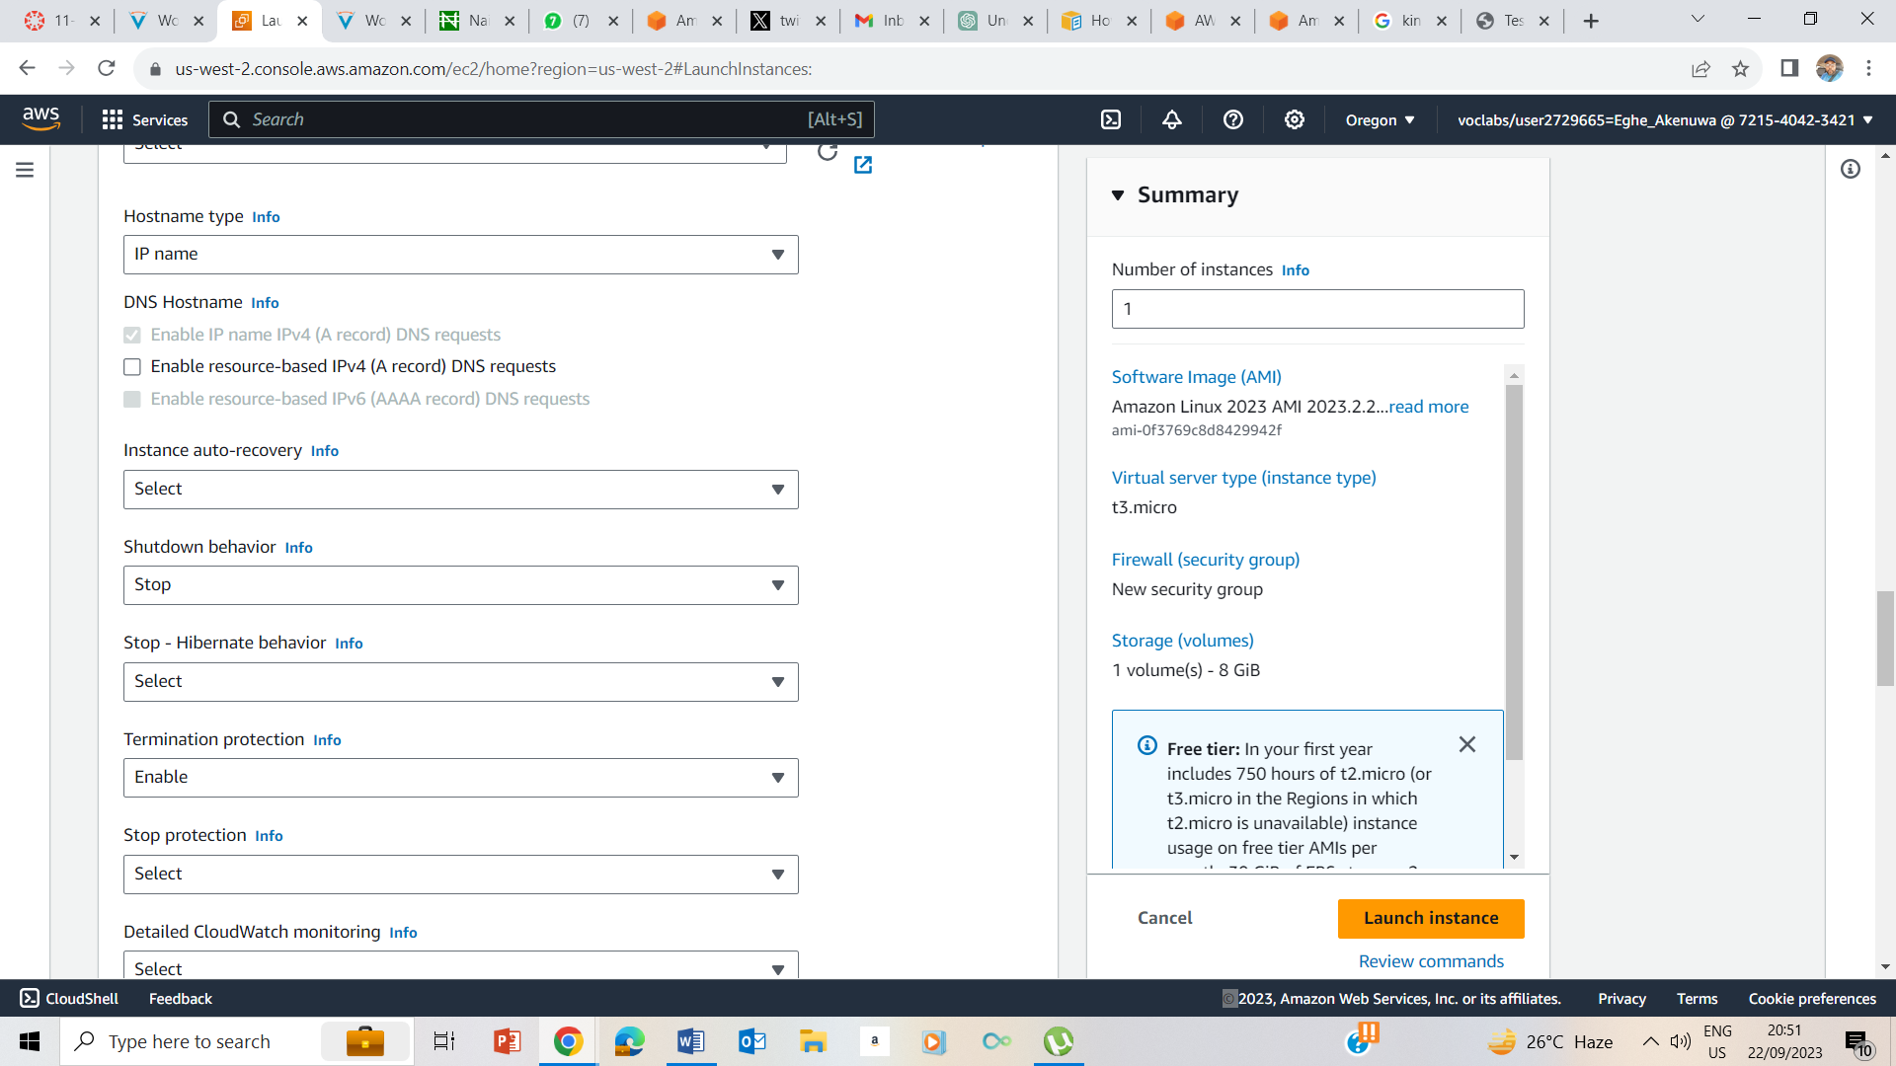

I enabled termination Protection

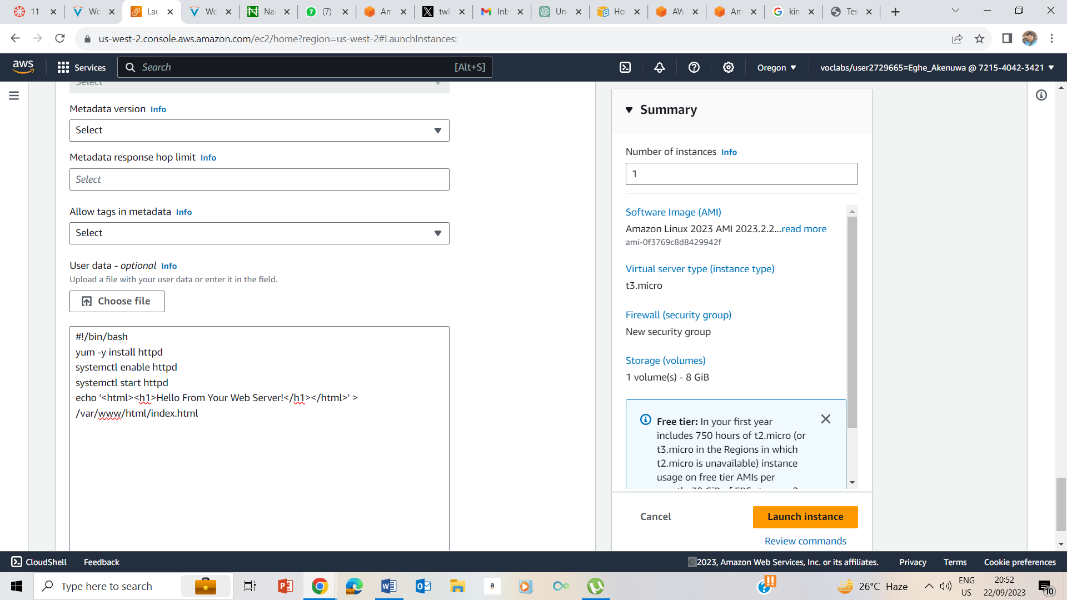

I pasted the bash script above in the user data.

The script does the following:

* Install an Apache web server (httpd)
* Configure the web server to automatically start on boot
* Activate the Web server
* Create a simple web pag

### Step 8: Launching an EC2 instance

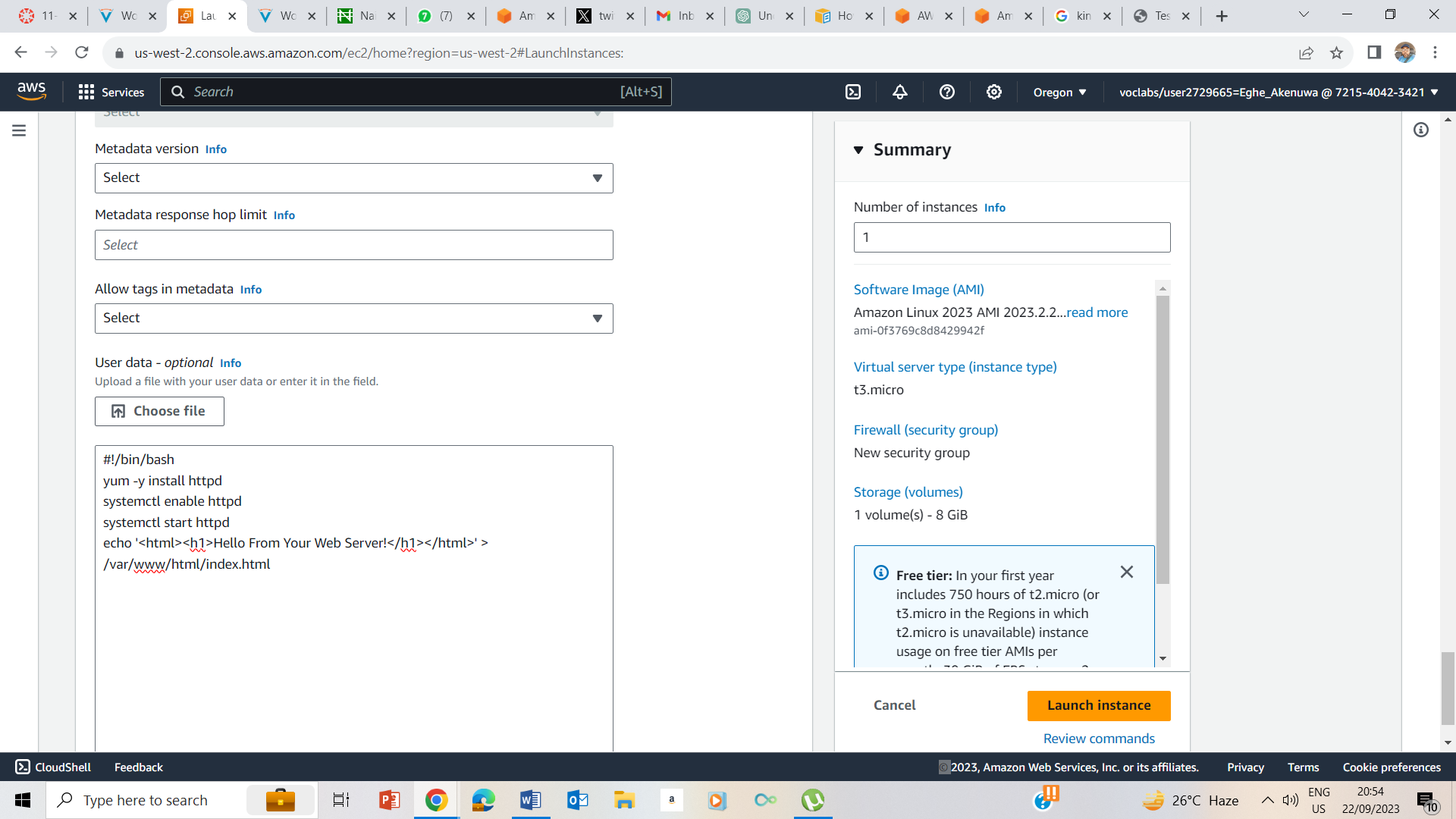

Clicked on Launch Instance

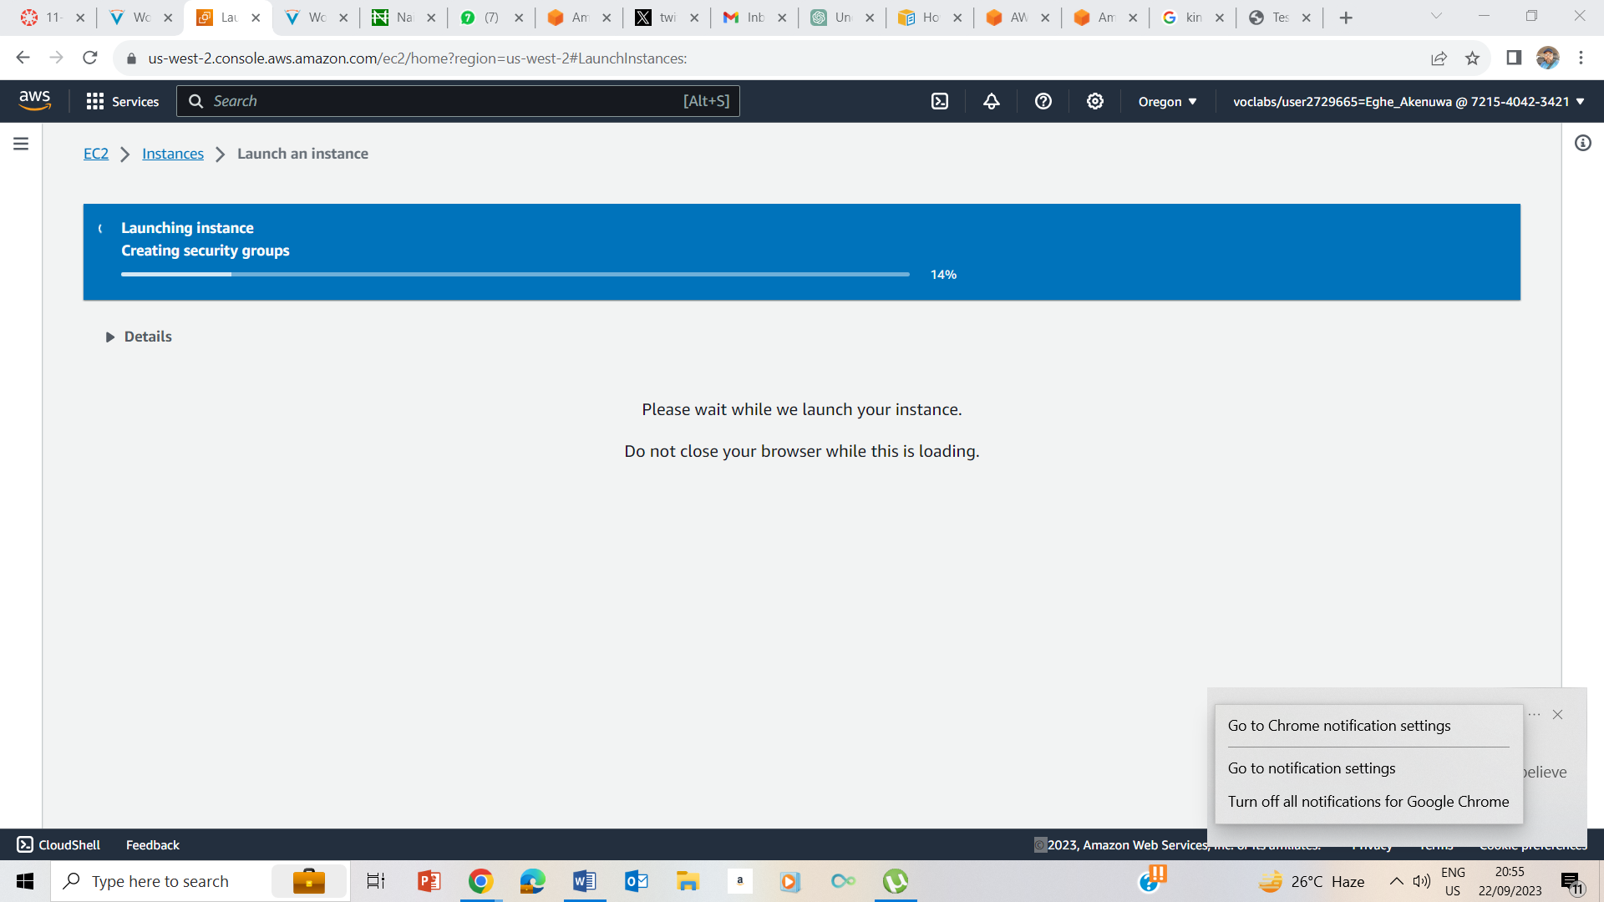

Launching Instance

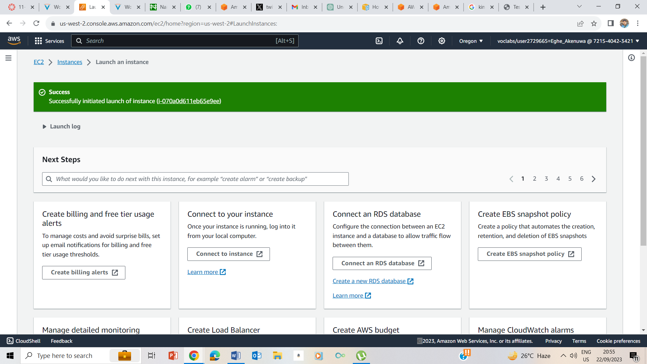Launched Instance

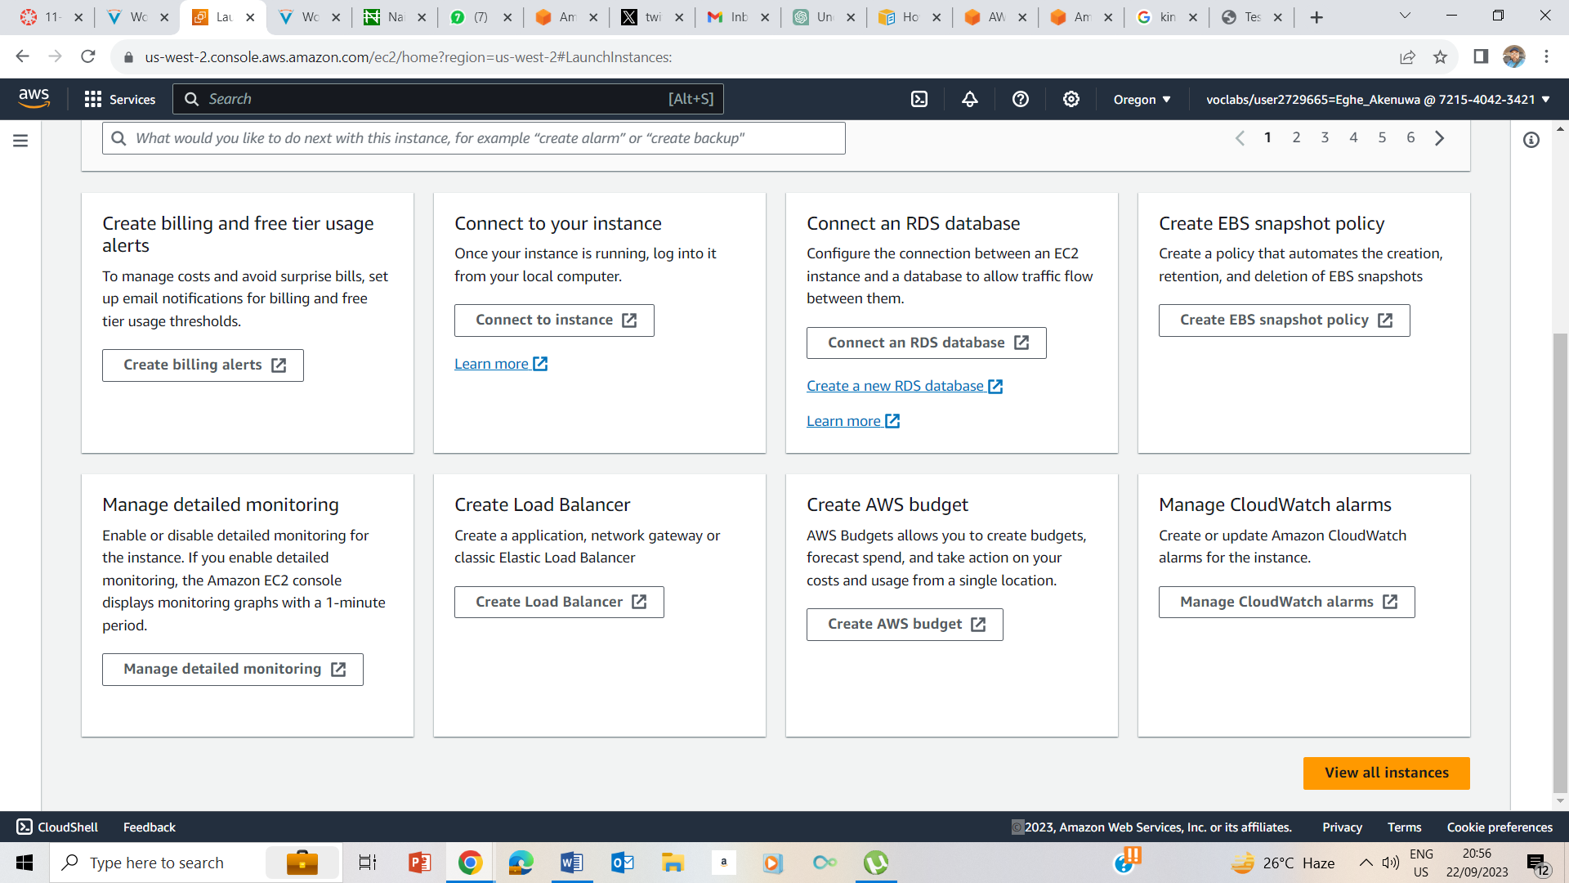

I clicked on View all Instances

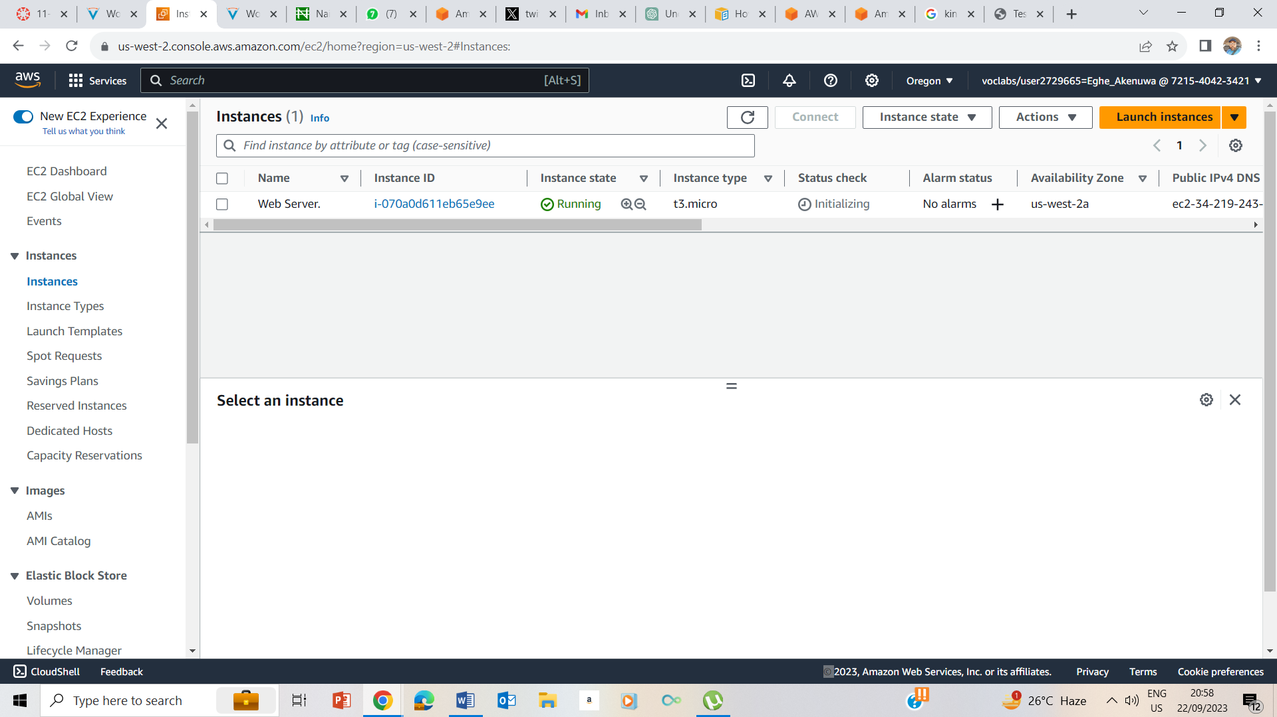

Instance in a running state

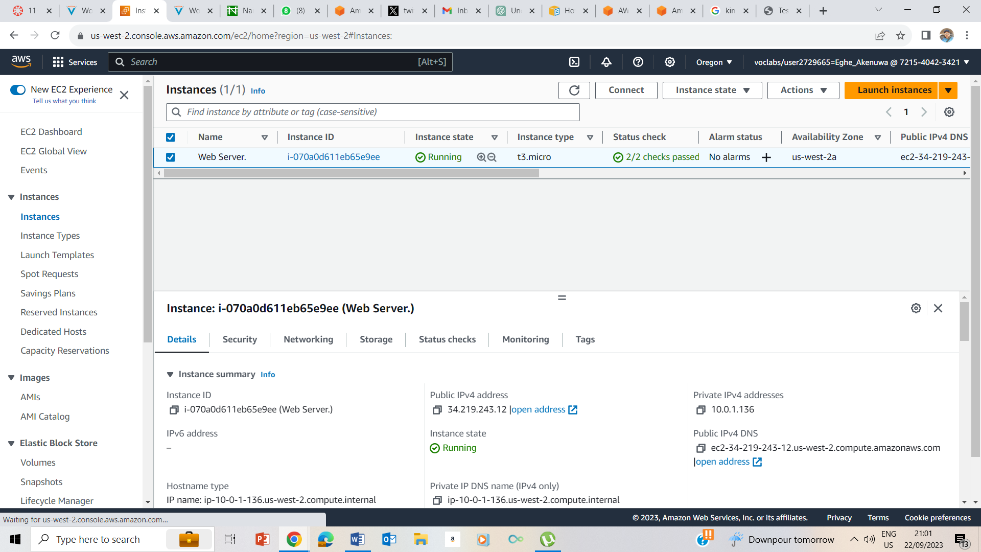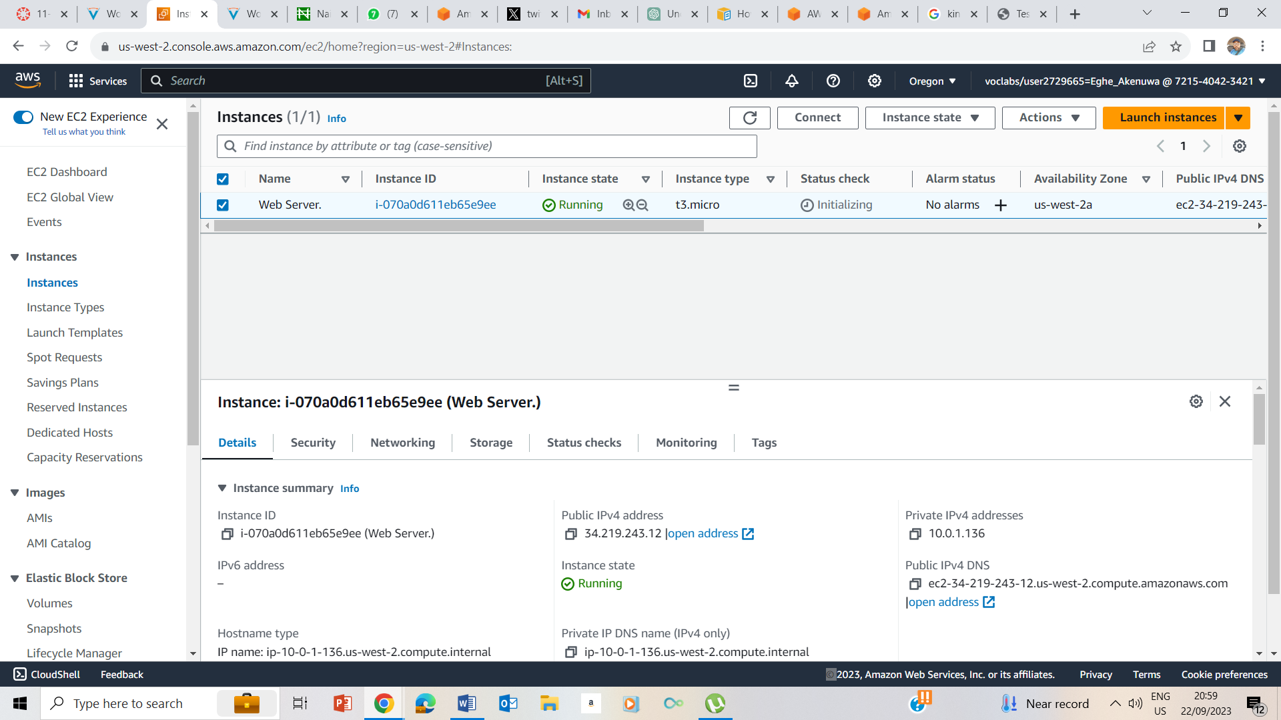

Instance check is running and status checks have 2/2 checks passed.

## Task 2: Monitor Your Instance

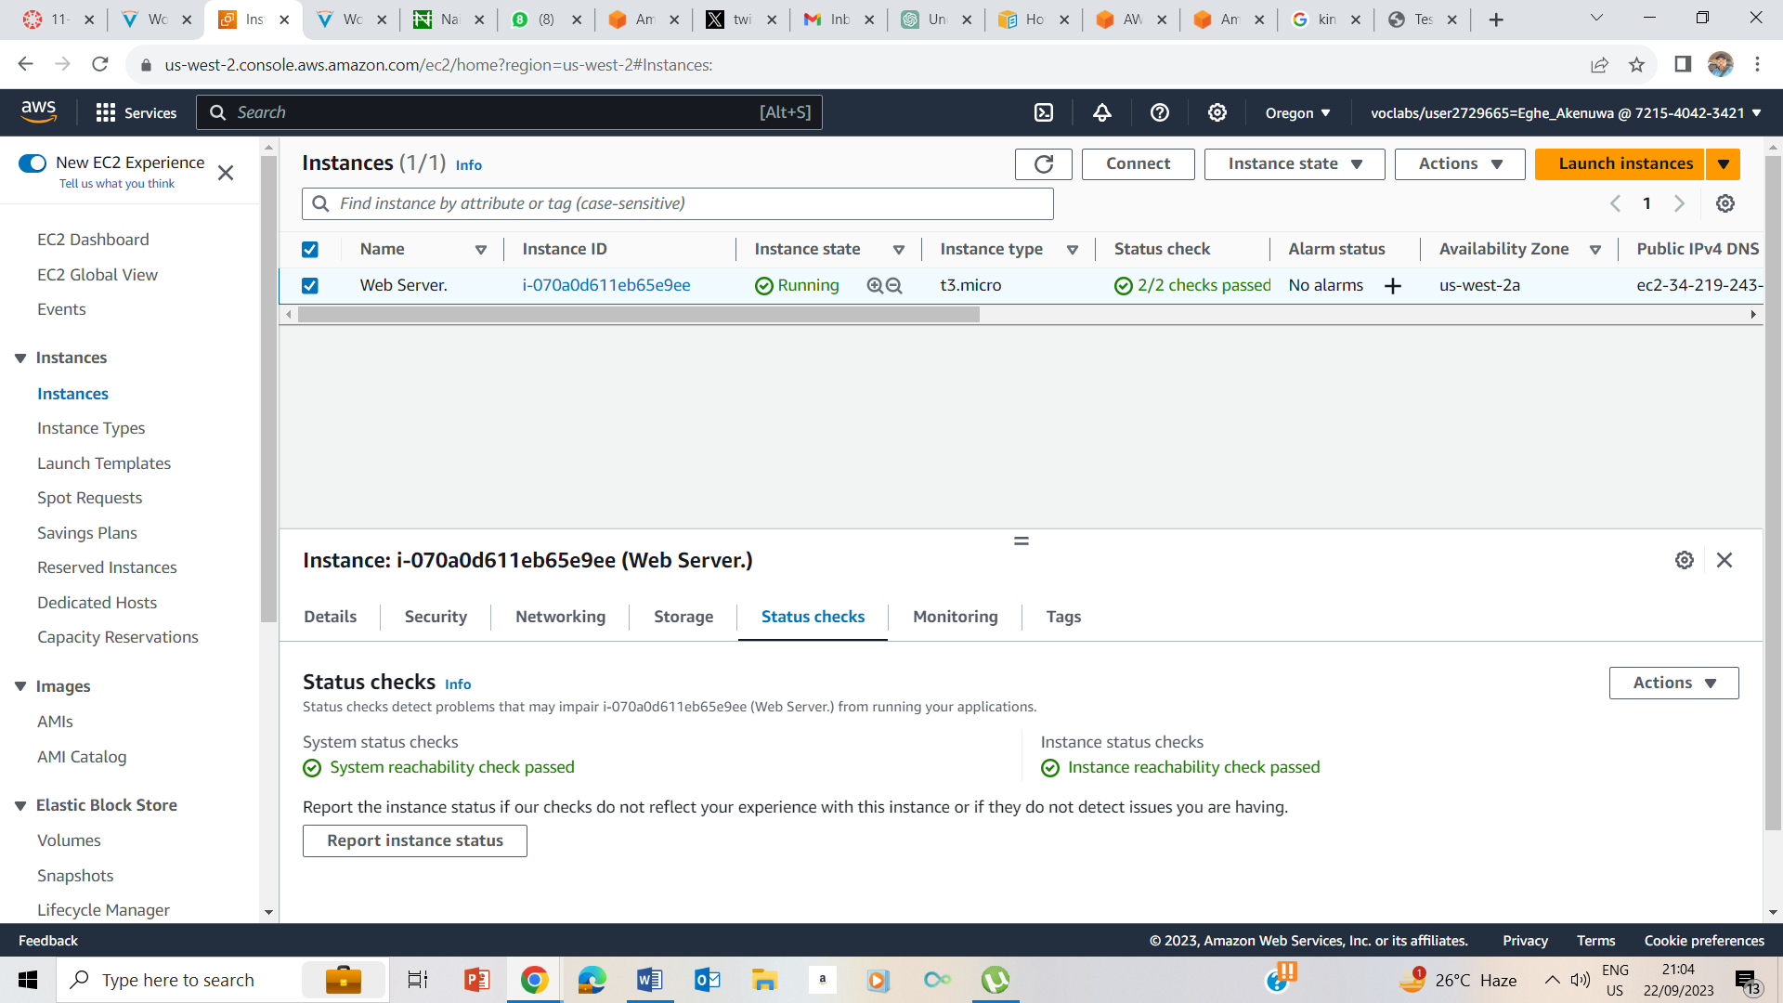

Status Check and Reliability check passed.

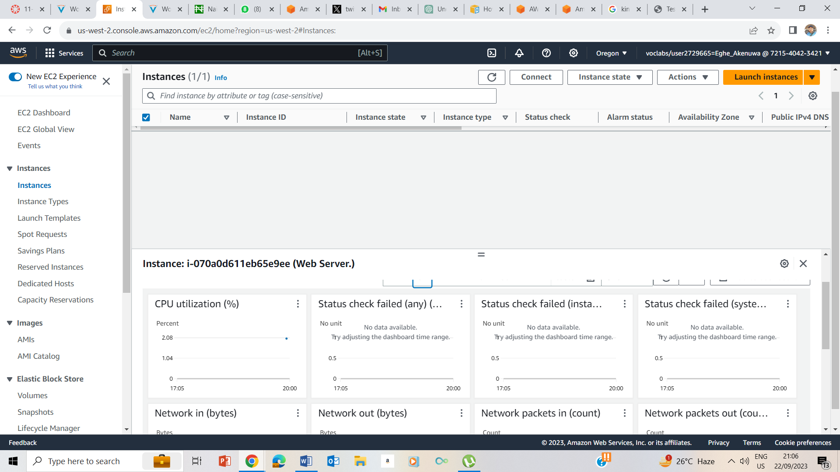

Amazon cloudwatch metrics for the instance

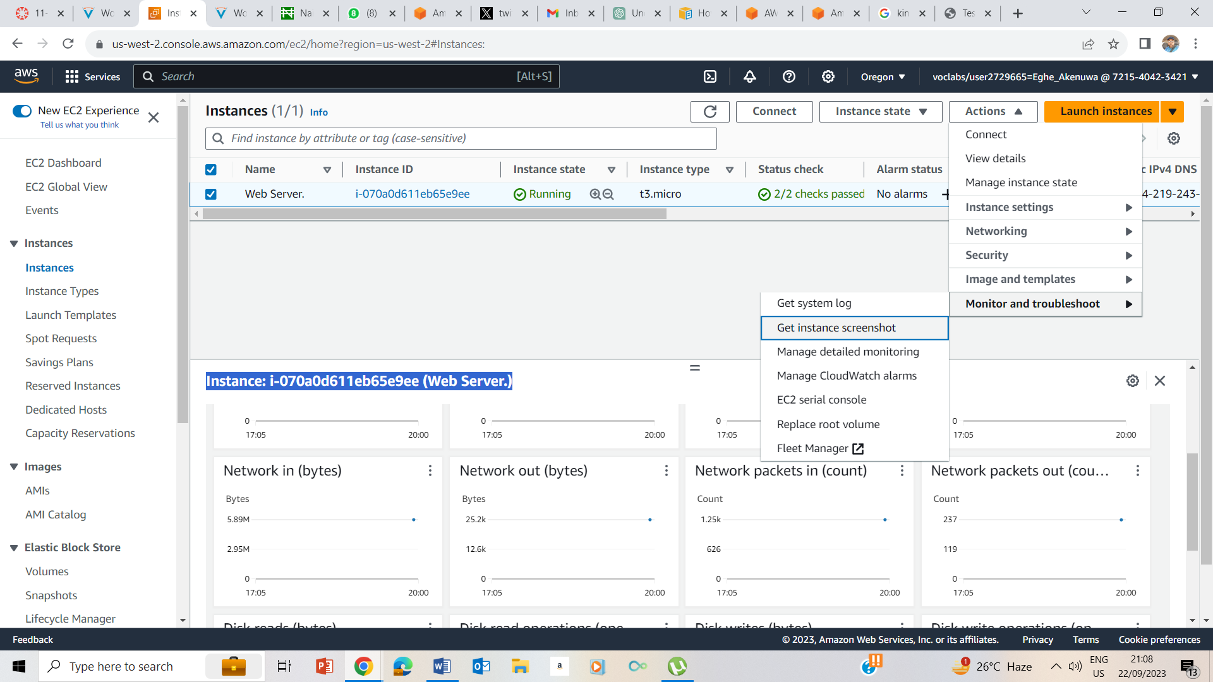

27. in the Actions Menu, I selected Monitor and troubleshoot-> Get instance screenshot

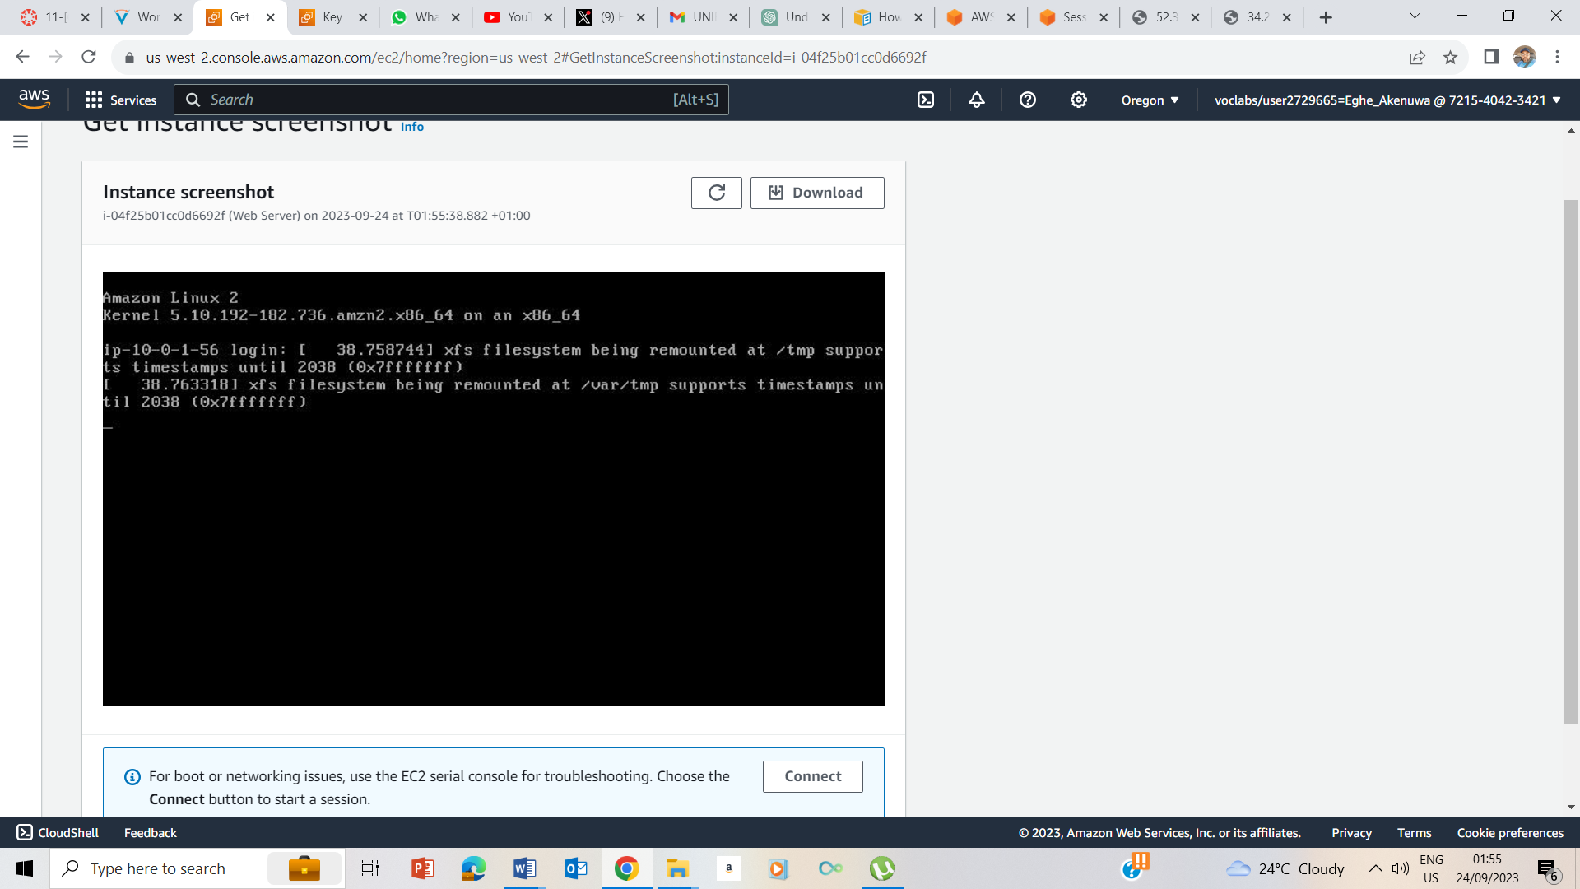

Instance screenshot

## Task 3: Update Your Security Group and Access the Web Server

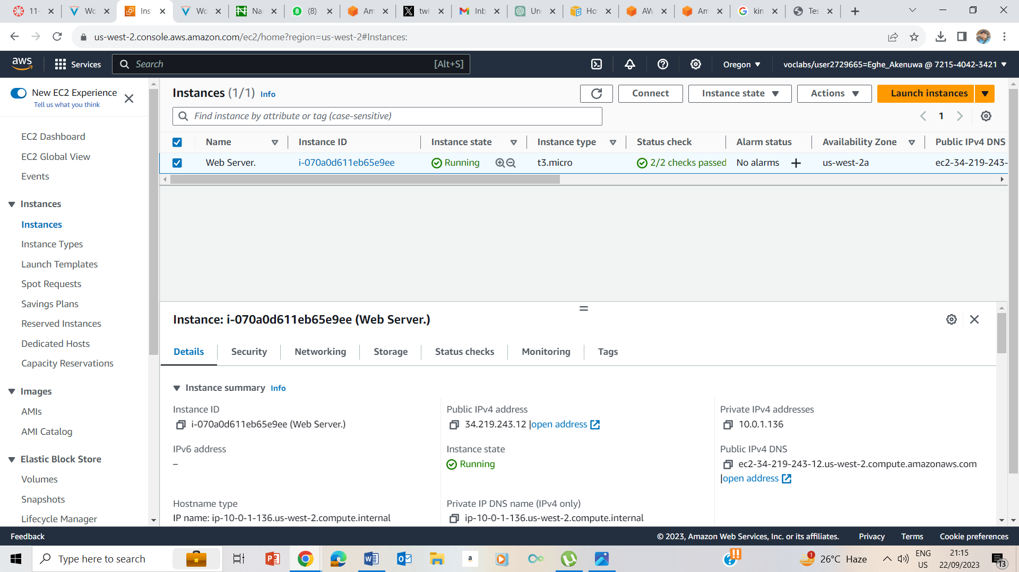

Details Tab

34.219.243.12 – IPV4 address

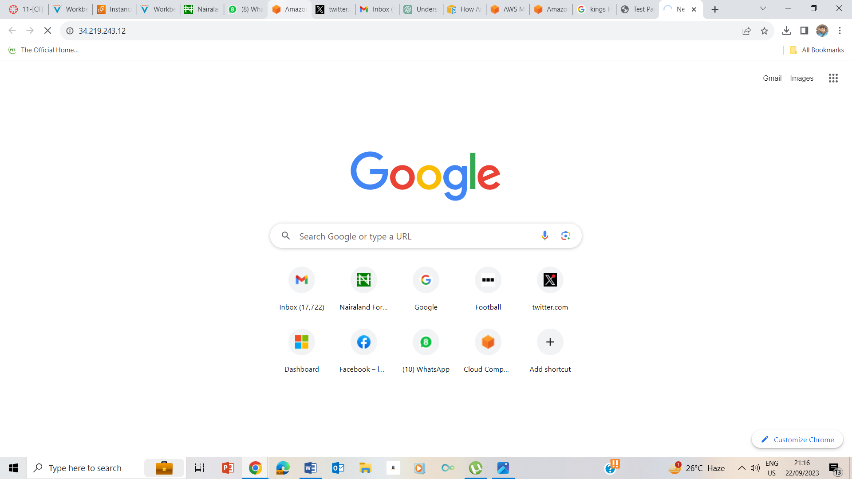

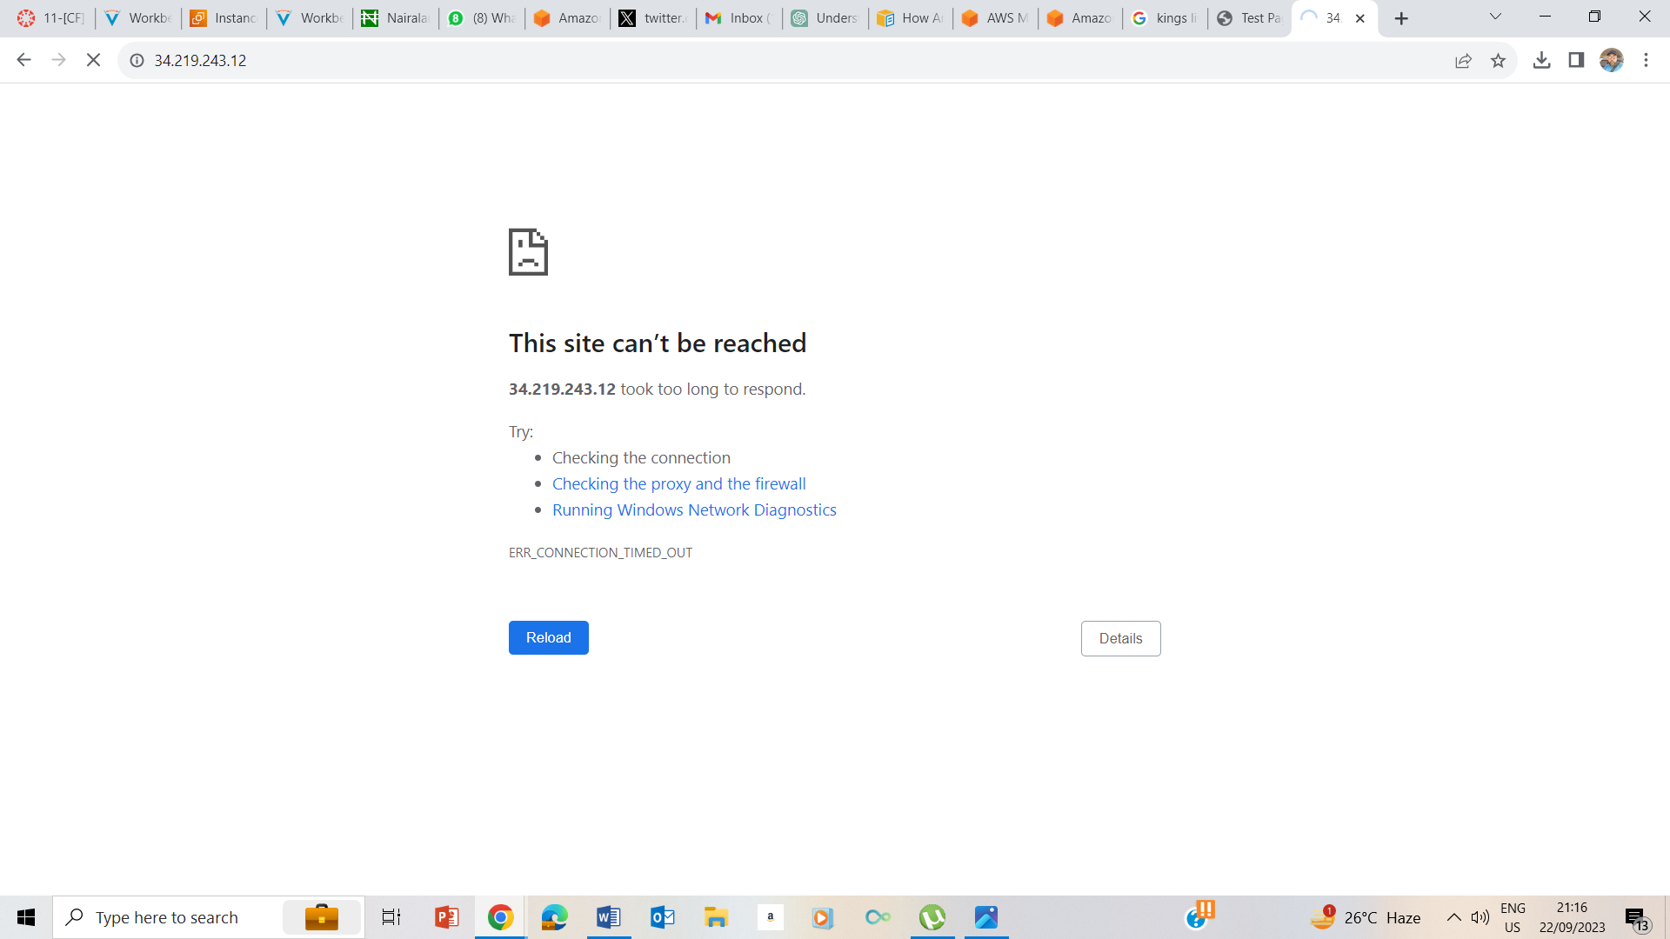

I could not access the web server because the security group is not permitting inbound traffic.

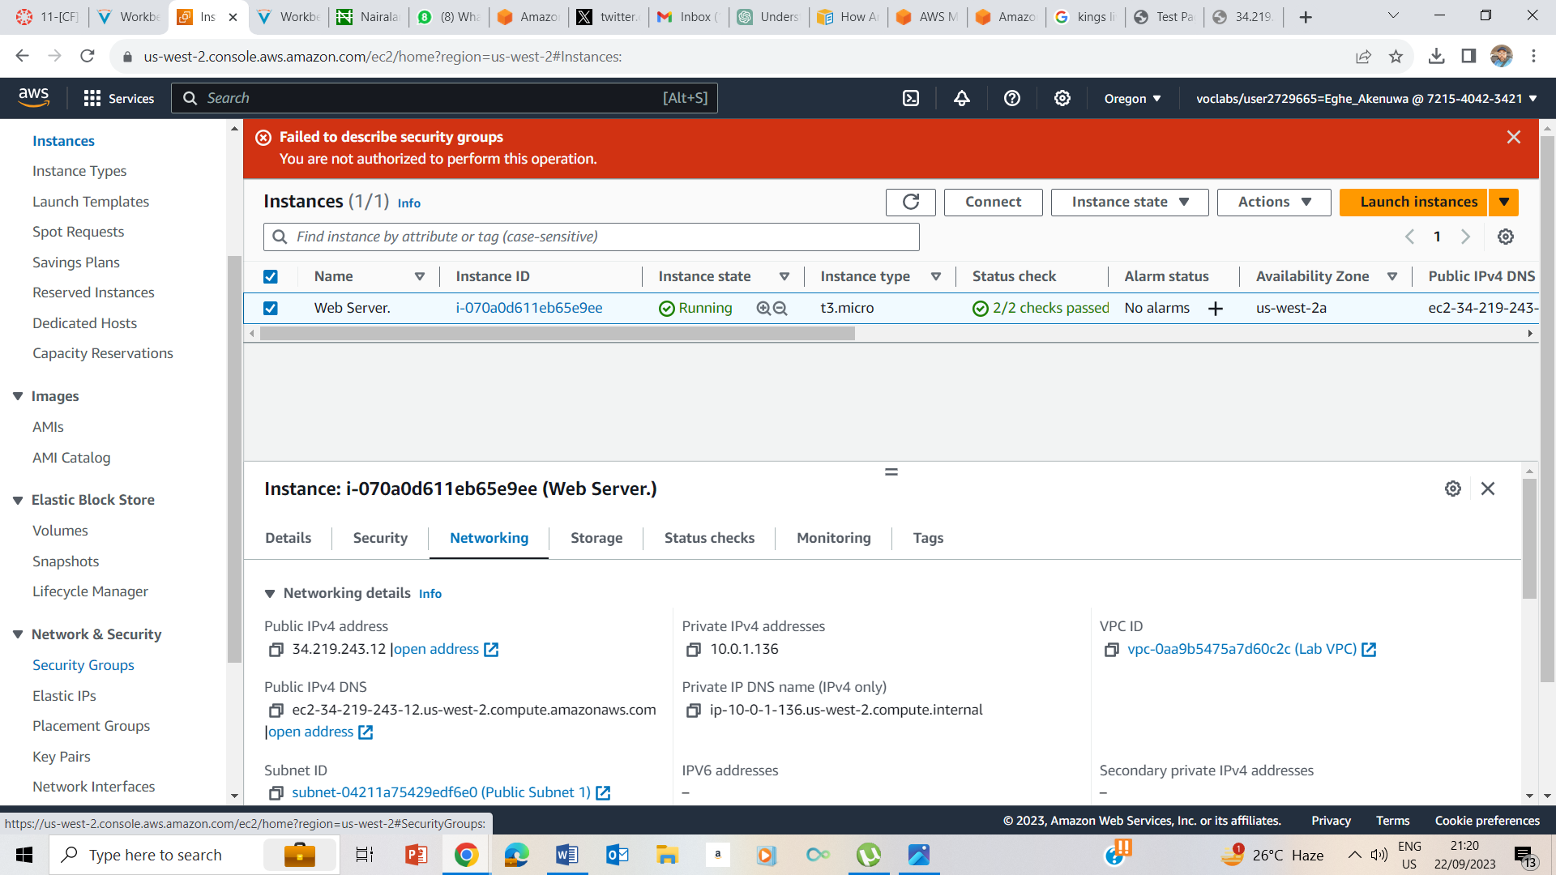

I clicked on the security groups under Network & Security in the left pane

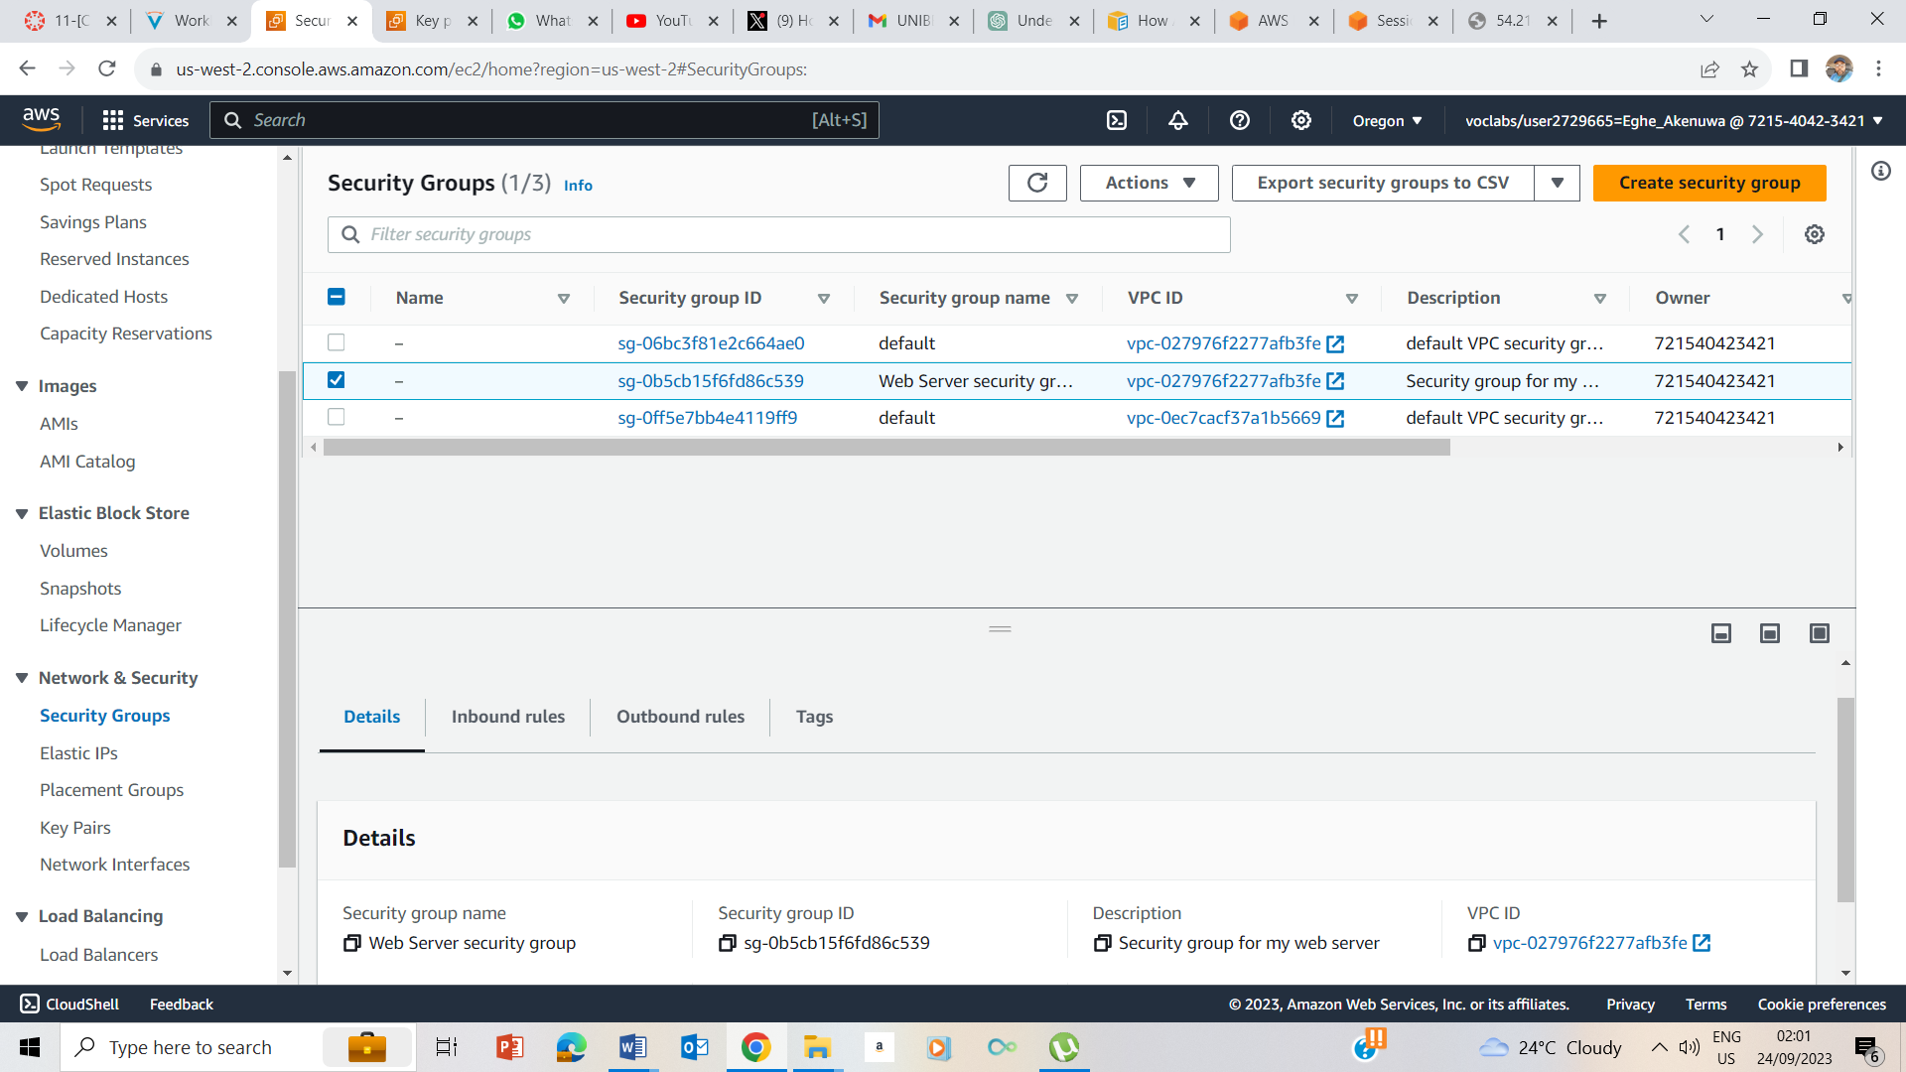

I clicked on web Server security groups

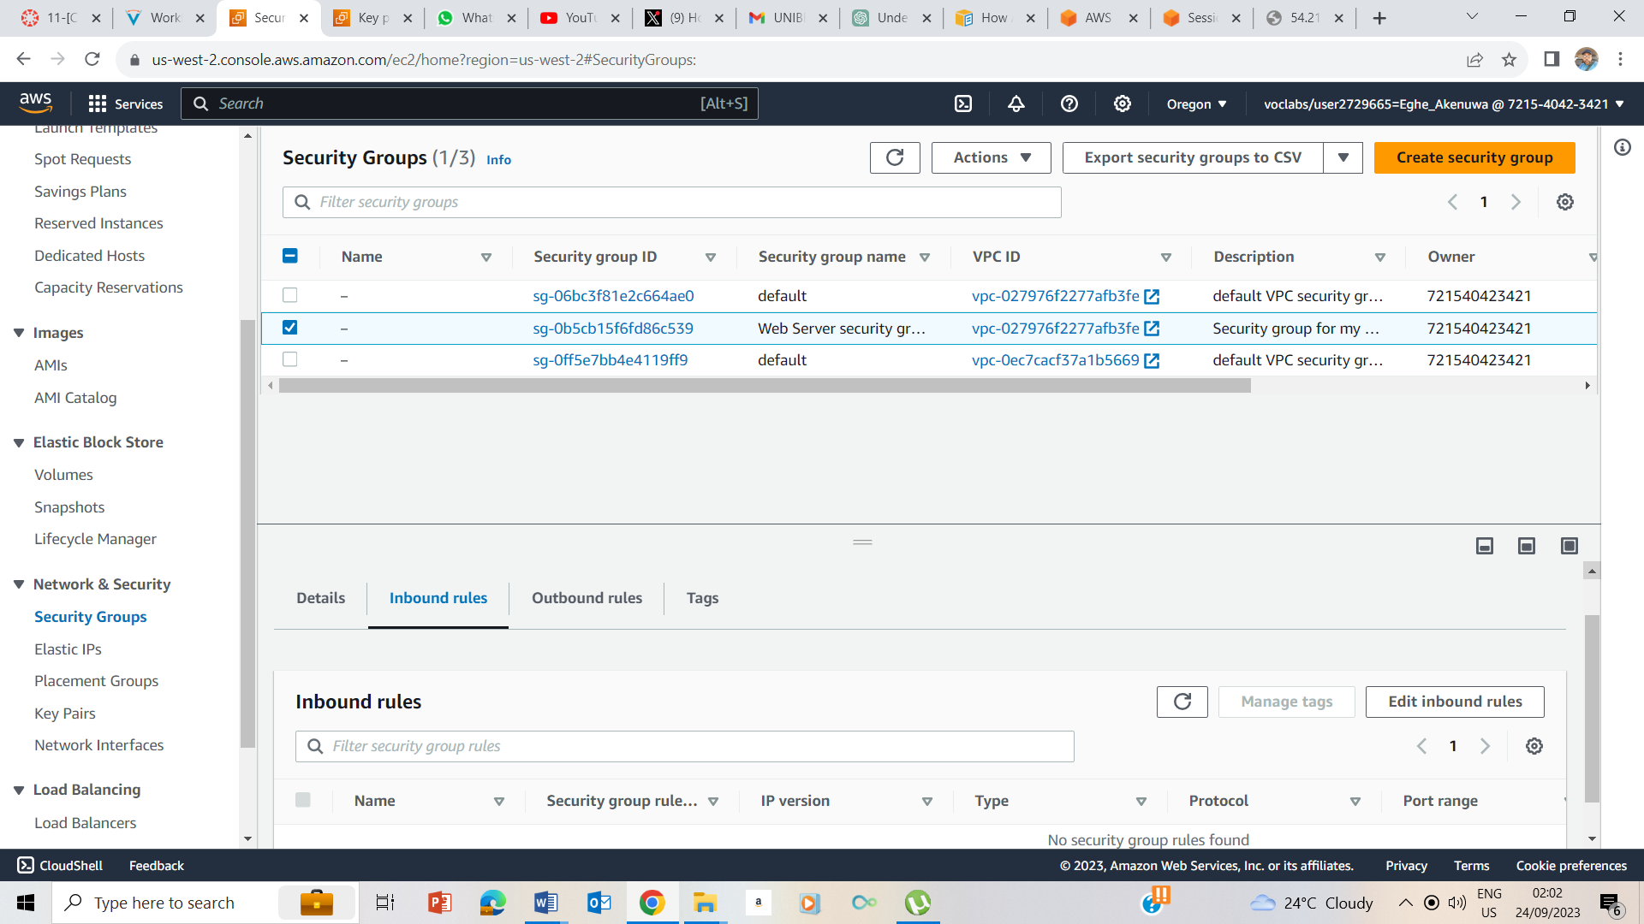

I clicked on Inbound Rules Tab

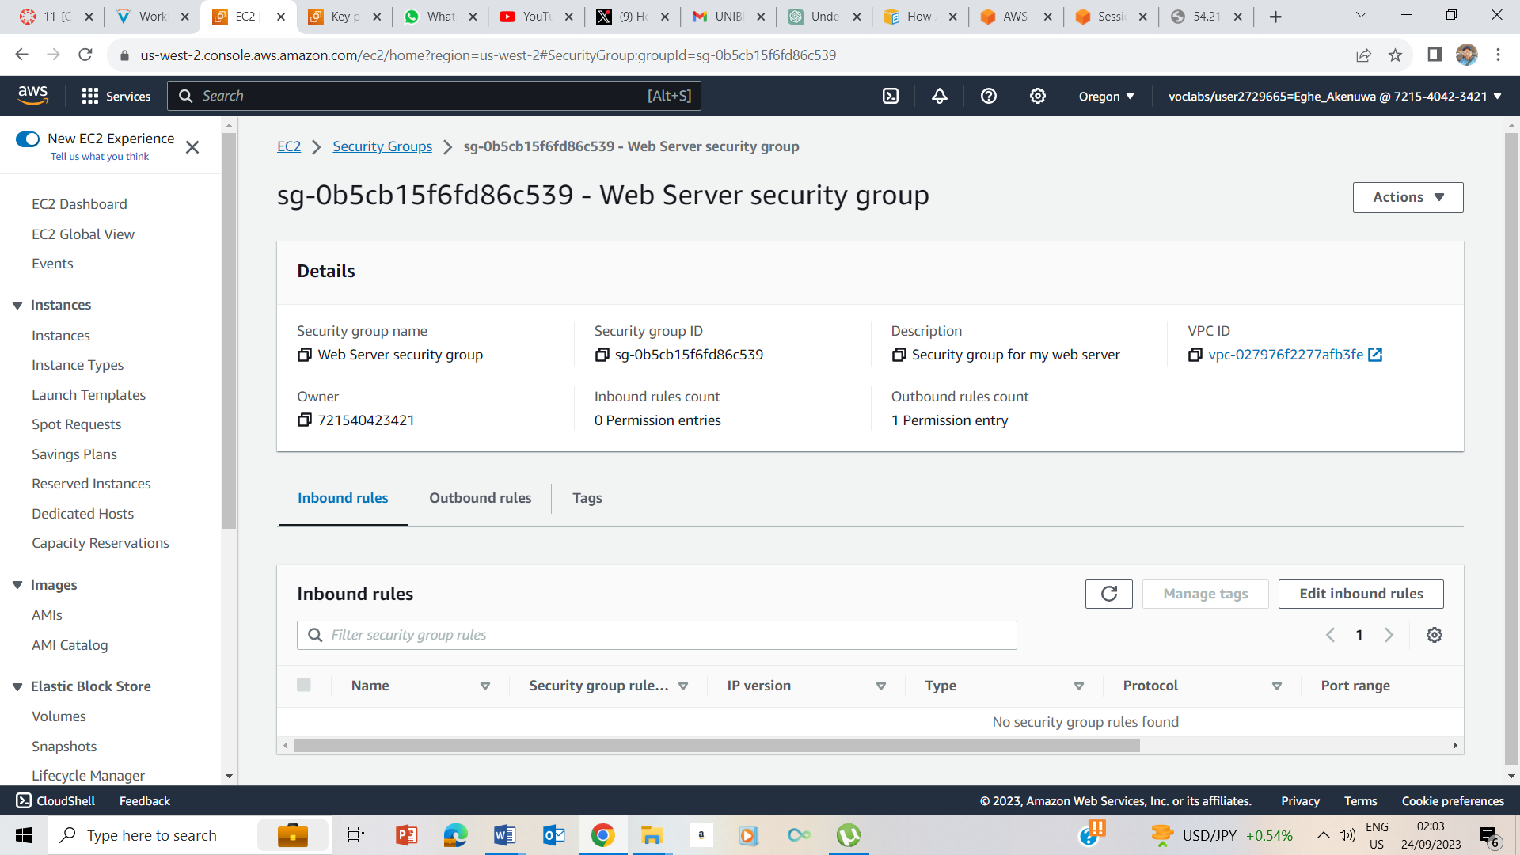

I clicked on Edit Inbound Rules

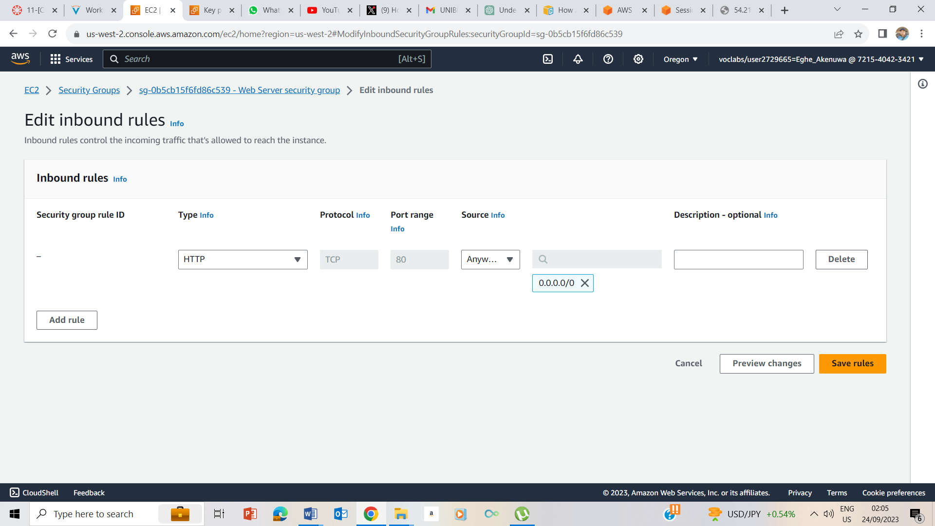

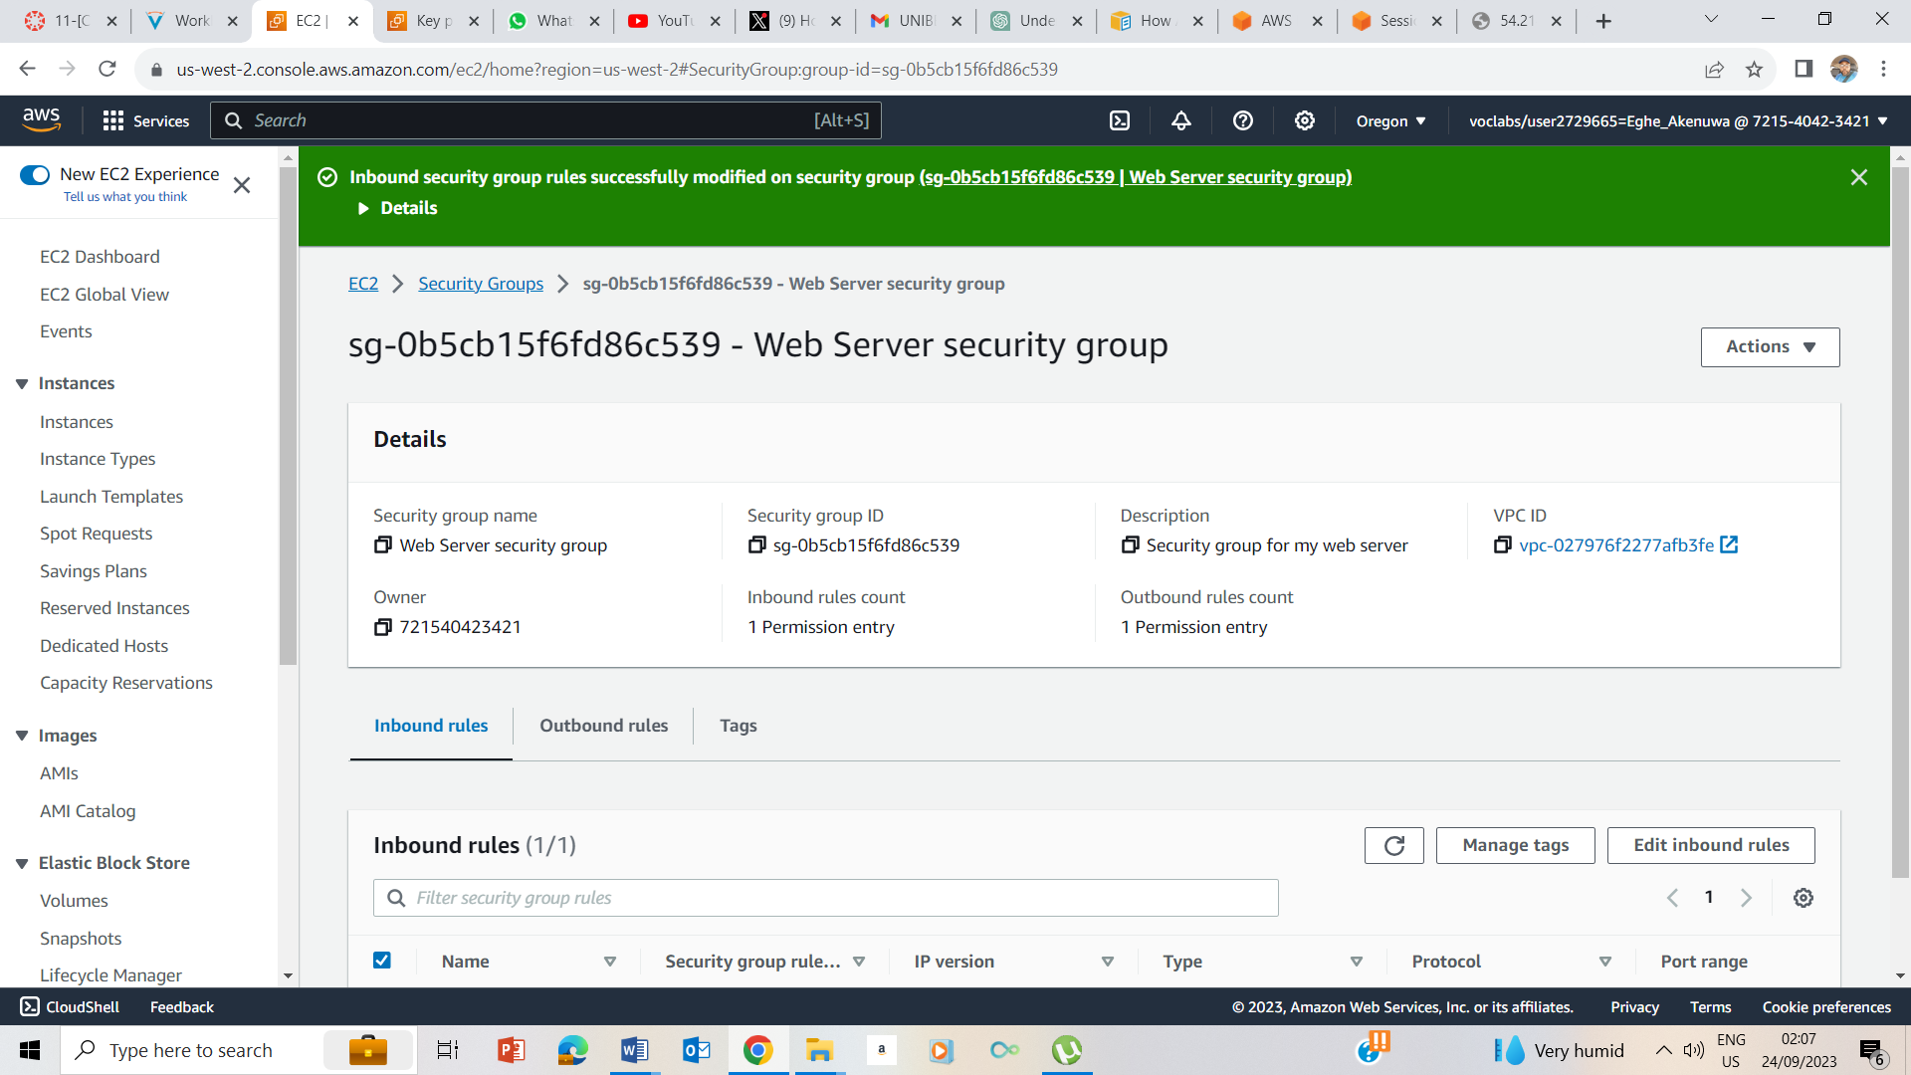

I selected Type as HTTP and Surce as Anywhere IPv4 selected save rules.

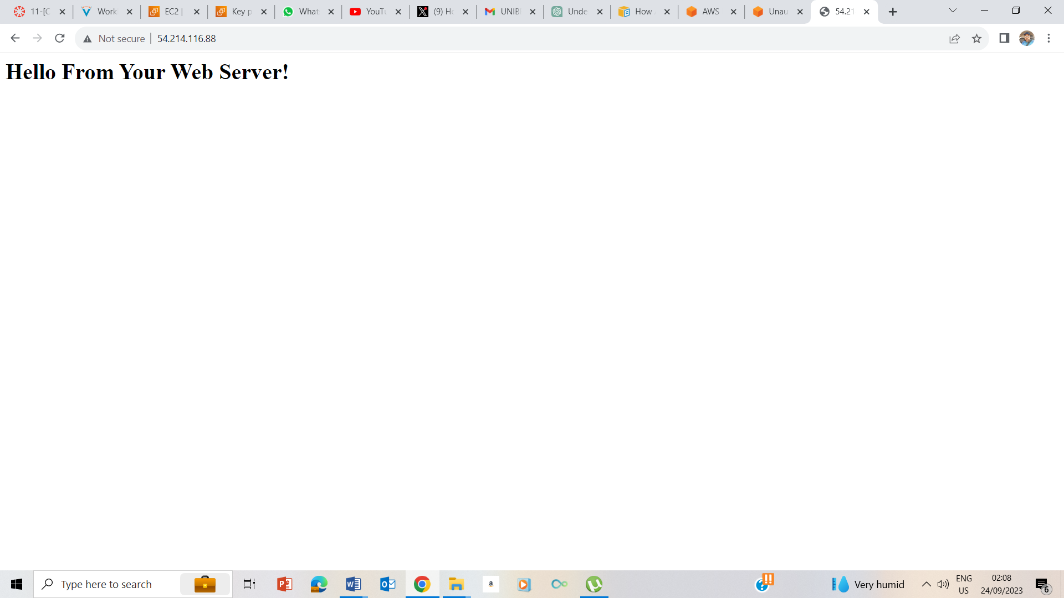

I returned to the previous web server that didn’t open and refreshed and got the message on the screenshot above.

## Task 4: Resize Your Instance: Instance Type and EBS Volume

### Stop Your Instance

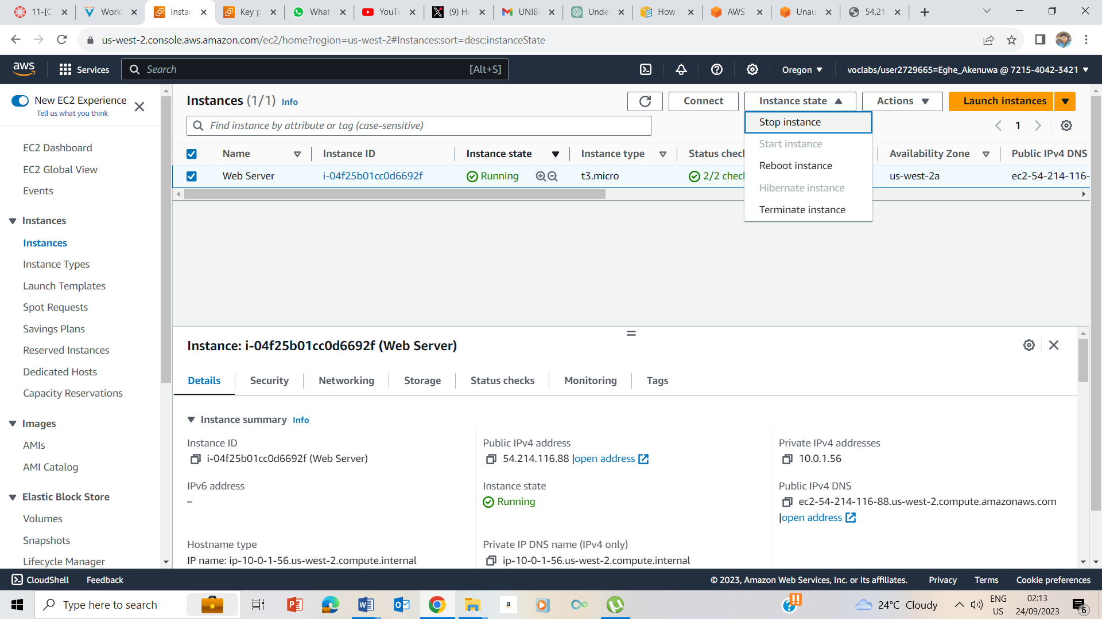

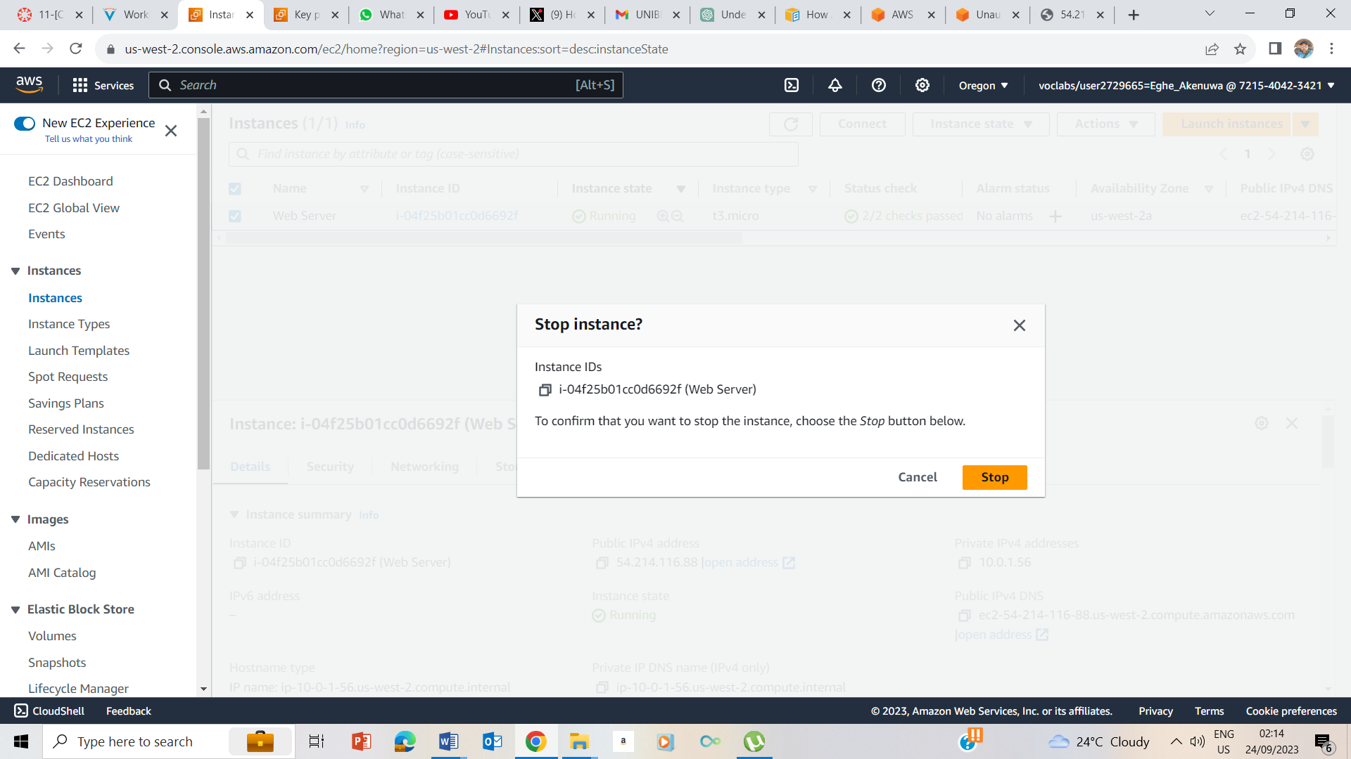

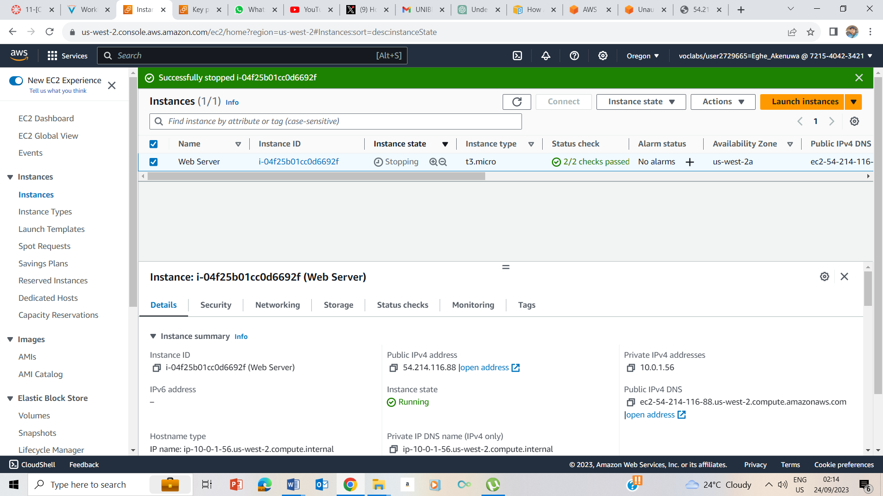

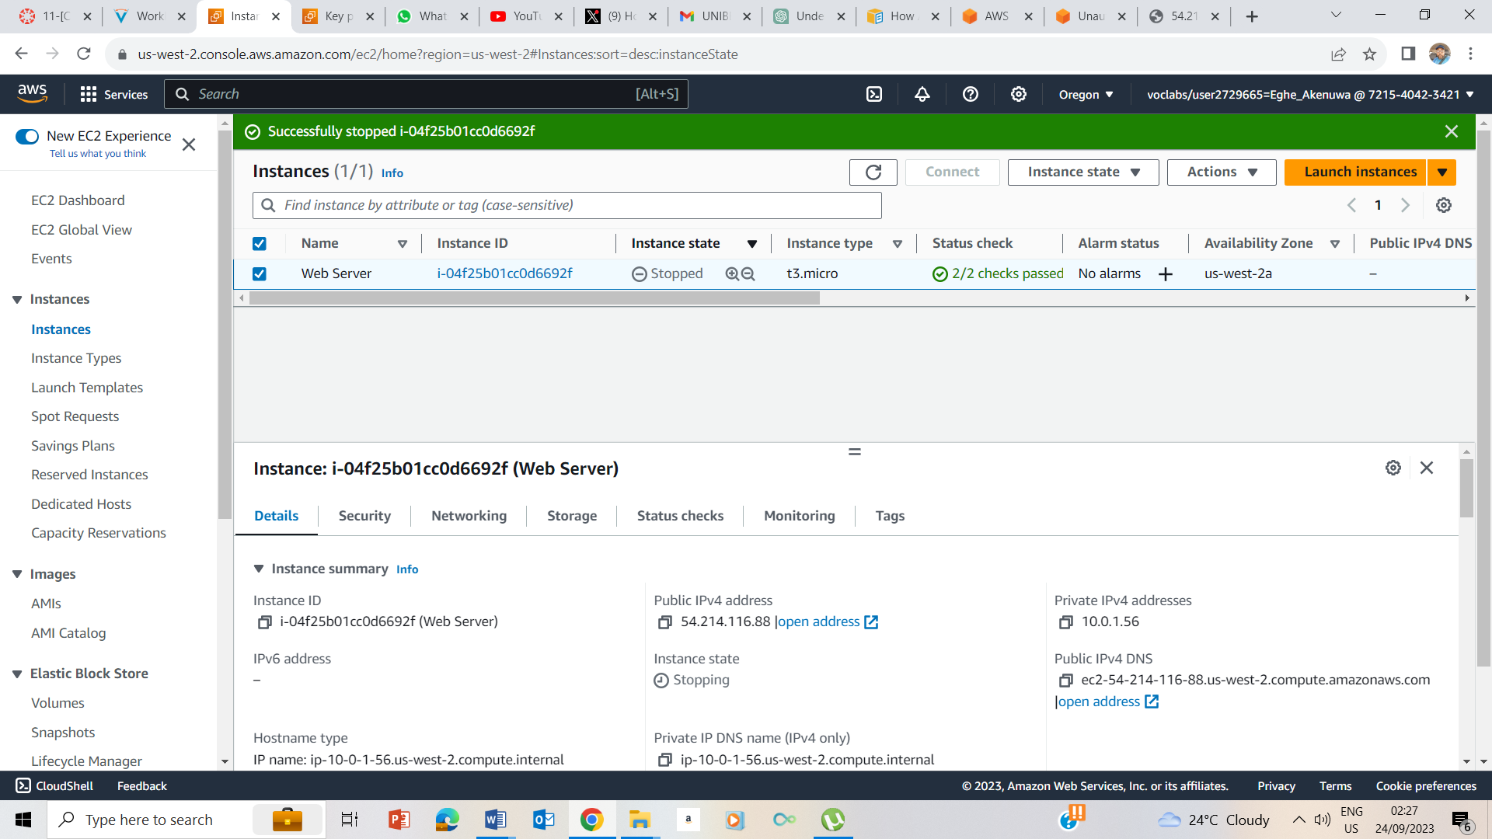

Instance Stopped

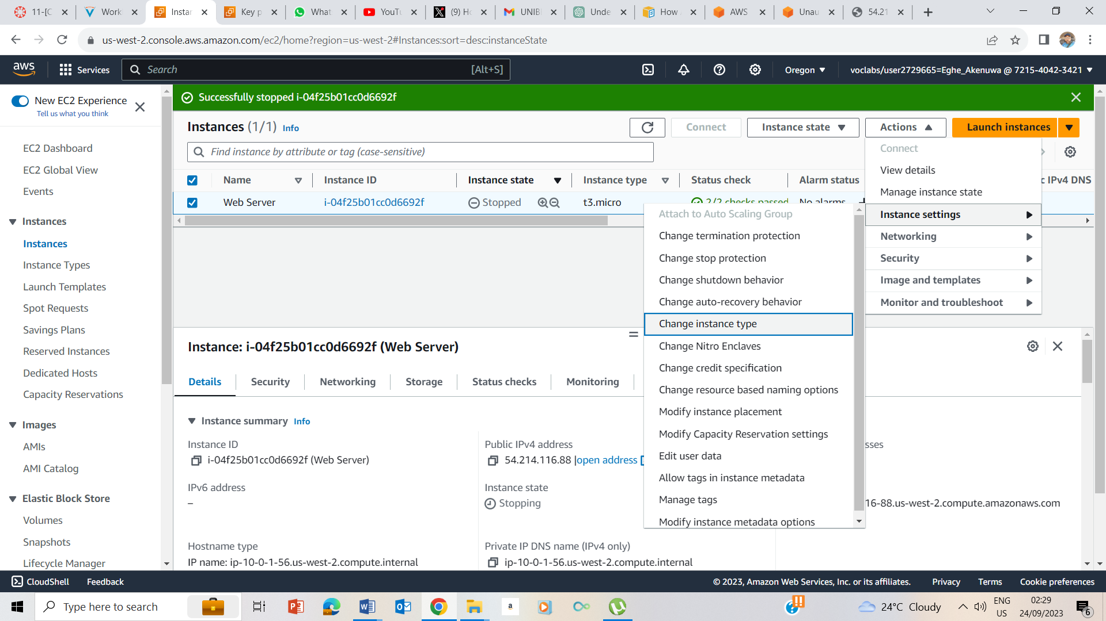

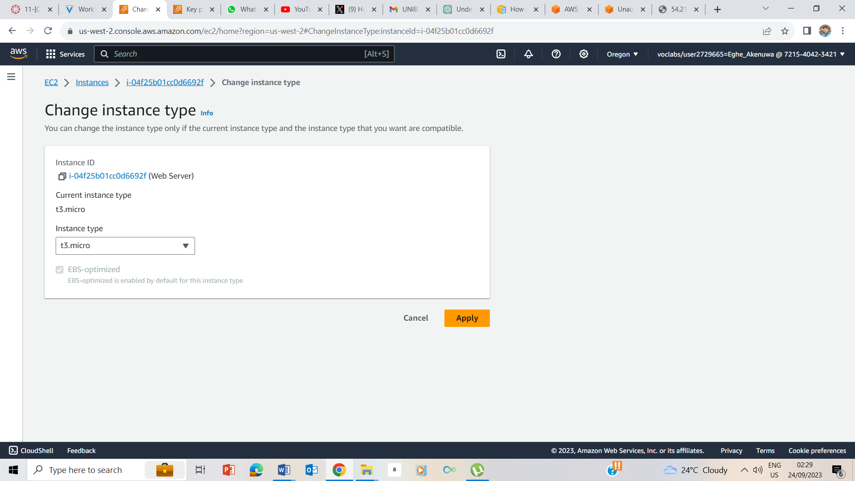

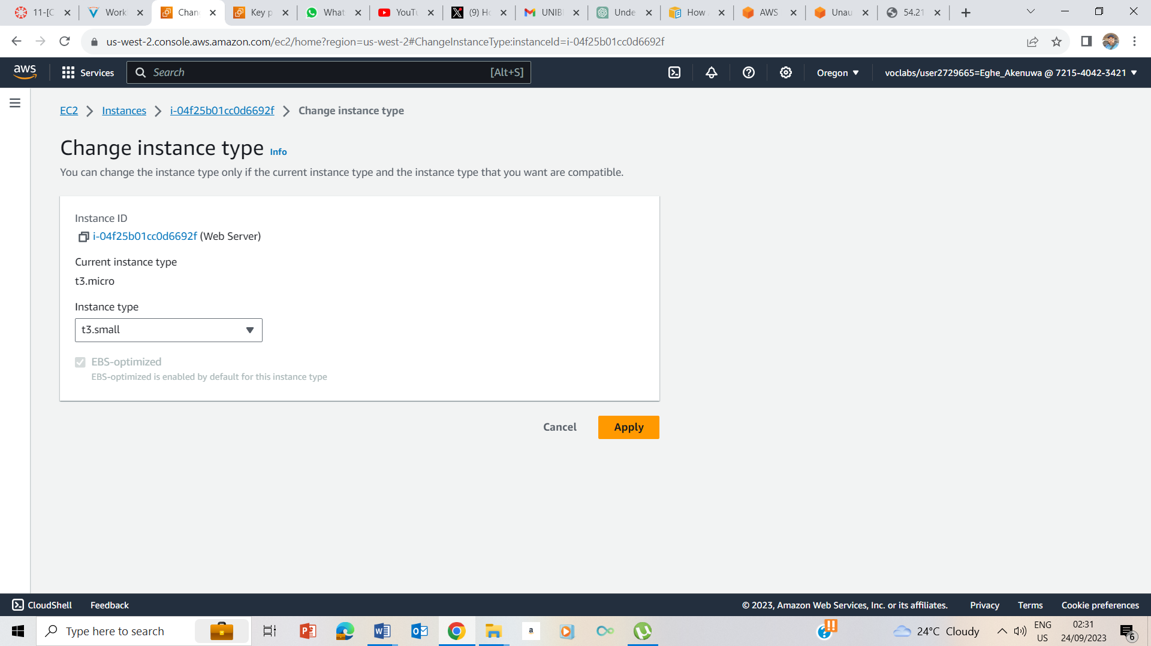

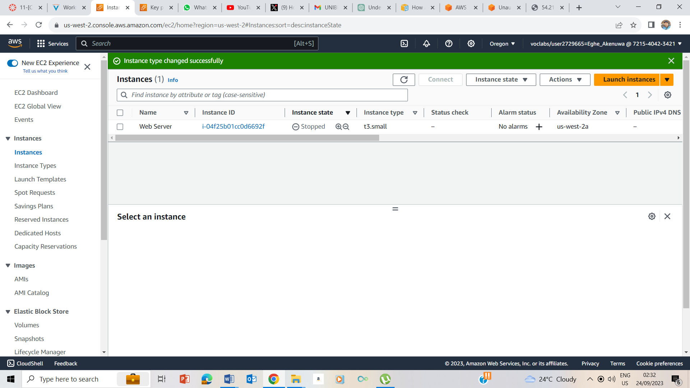

Changed the instance type from t3.micro to t3.small and selected Apply

### Resize the EBS Volume

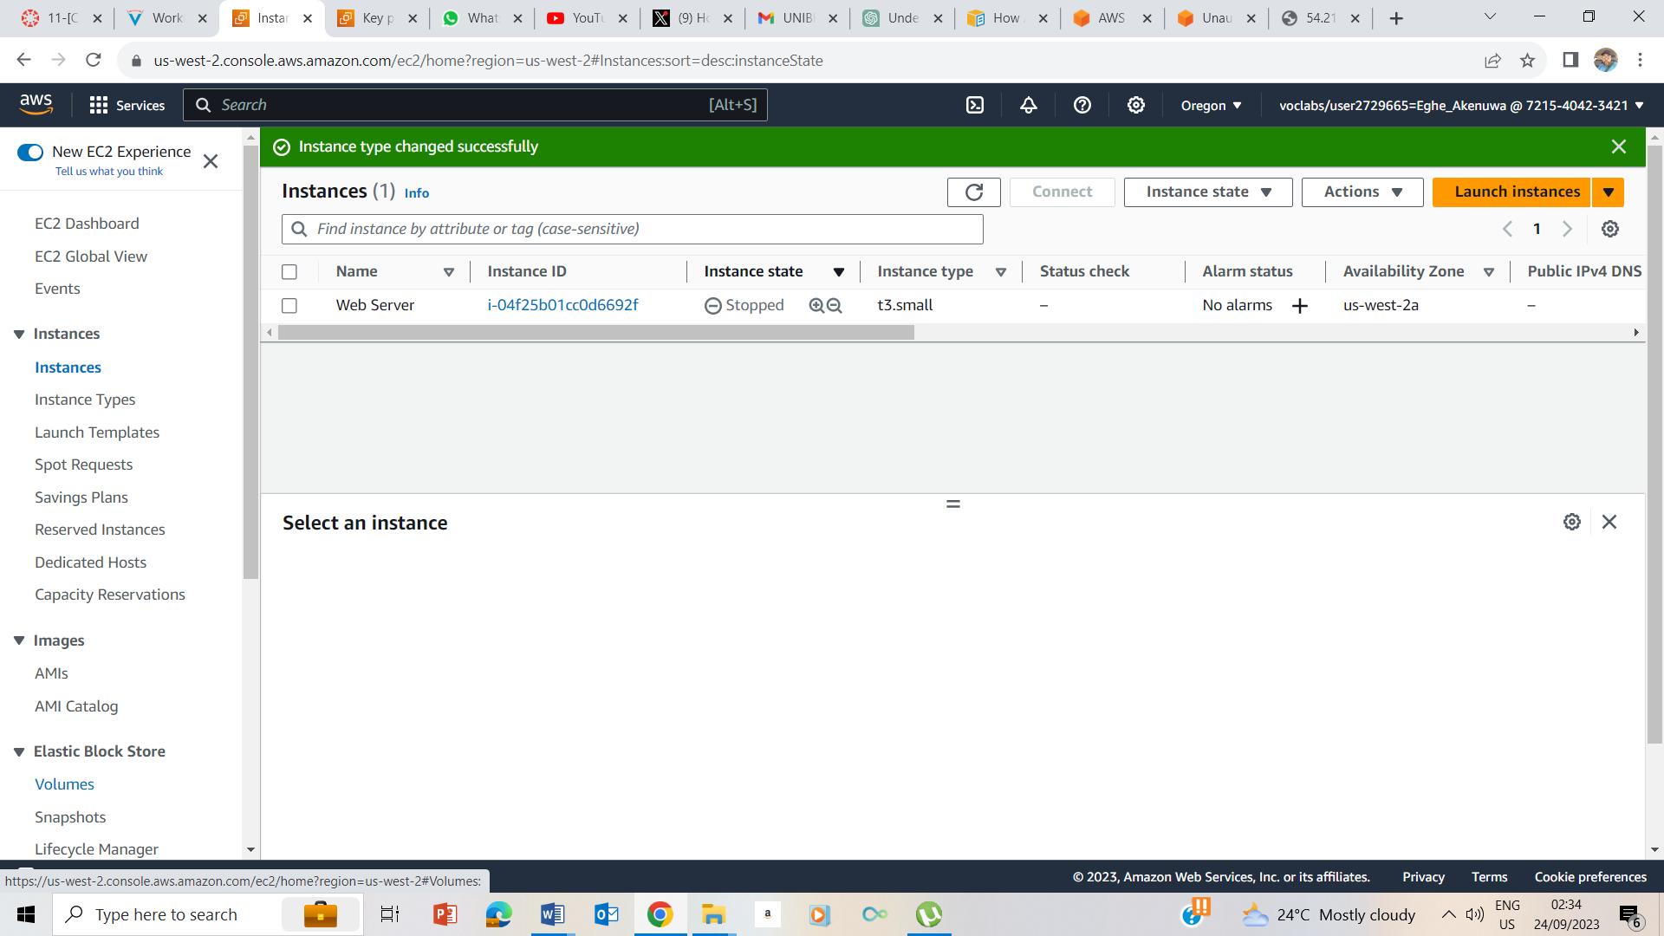

I selected volumes under the Elastic Block Store

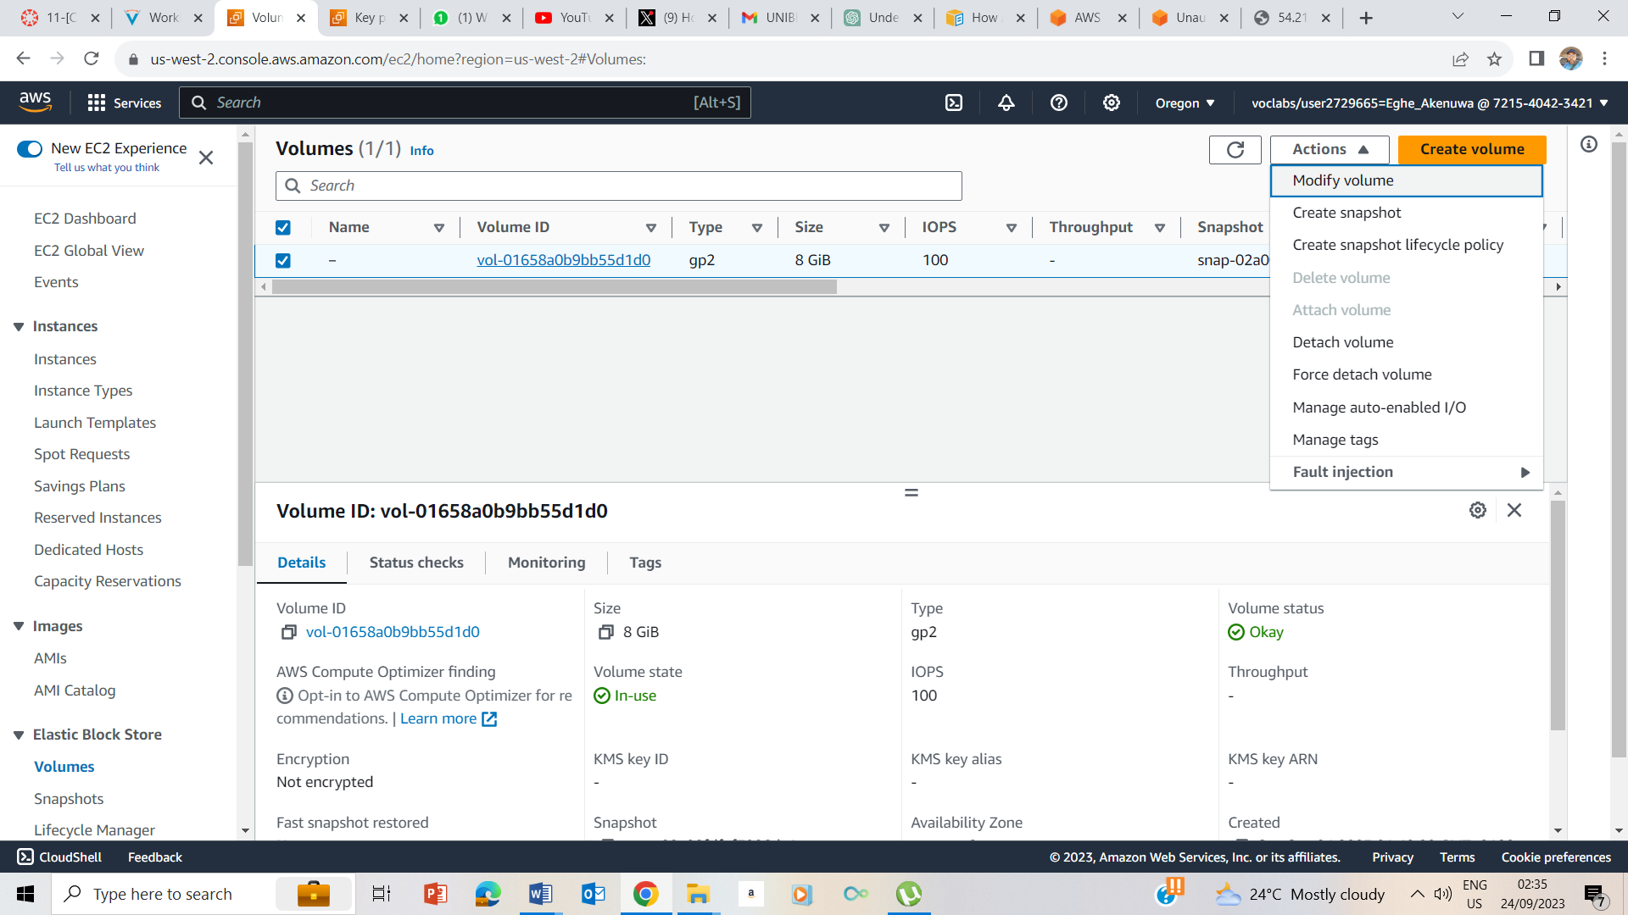

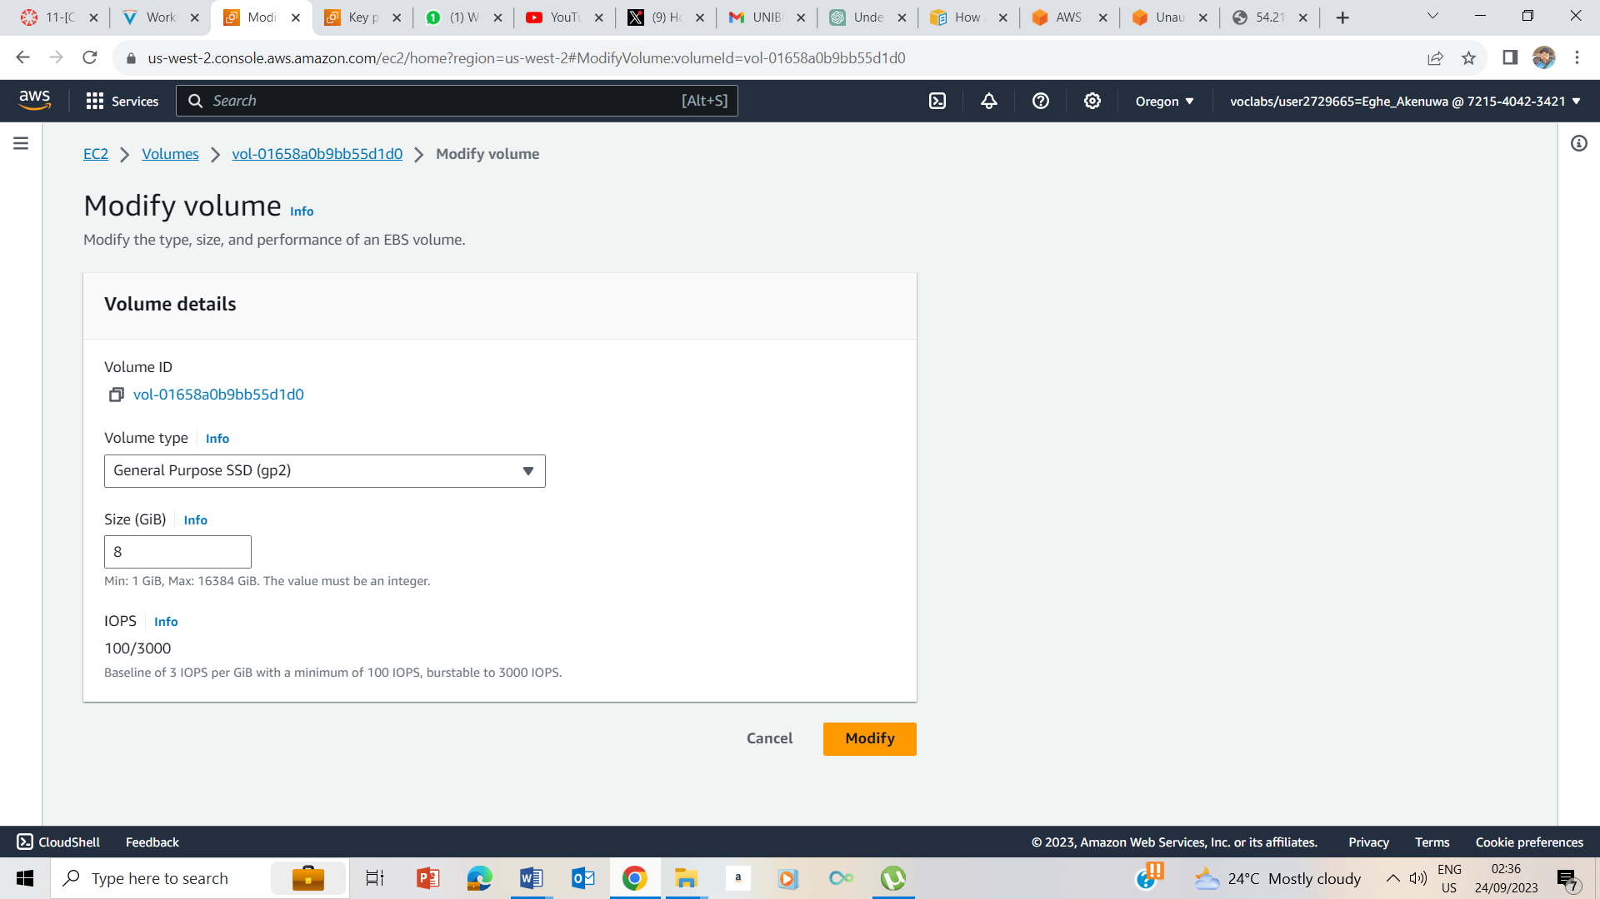

I selected Modify volumes.

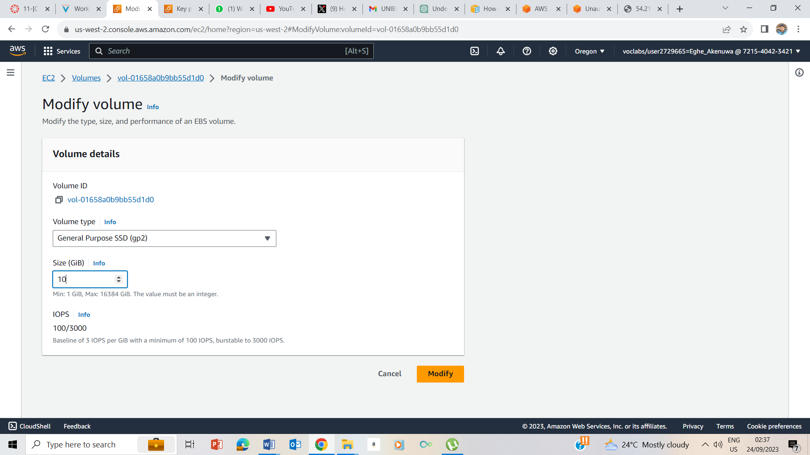

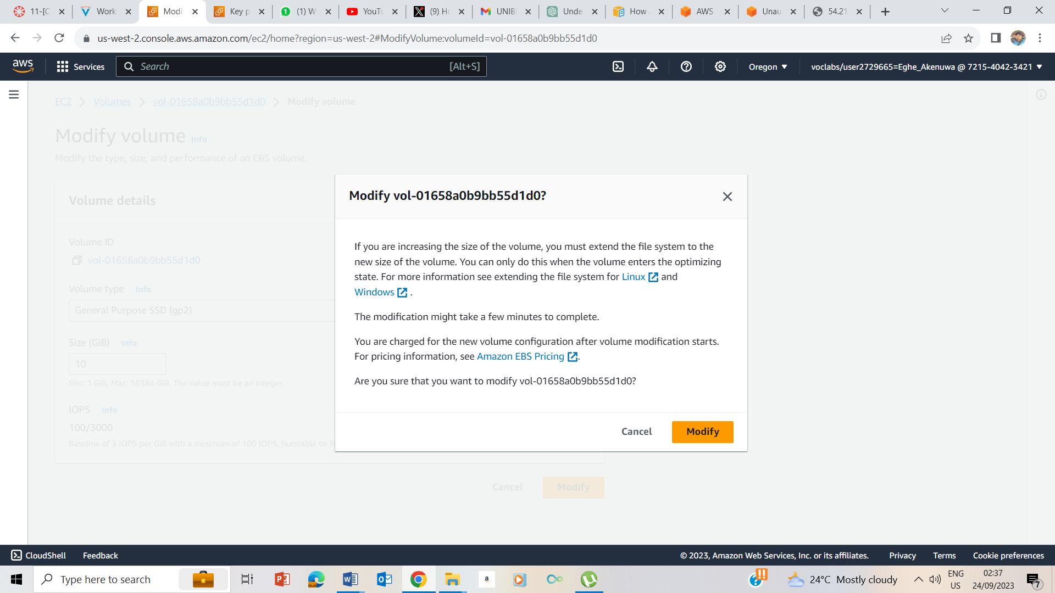

I changed the volume from 8 to 10 and selected modify

### Start the Resized Instance

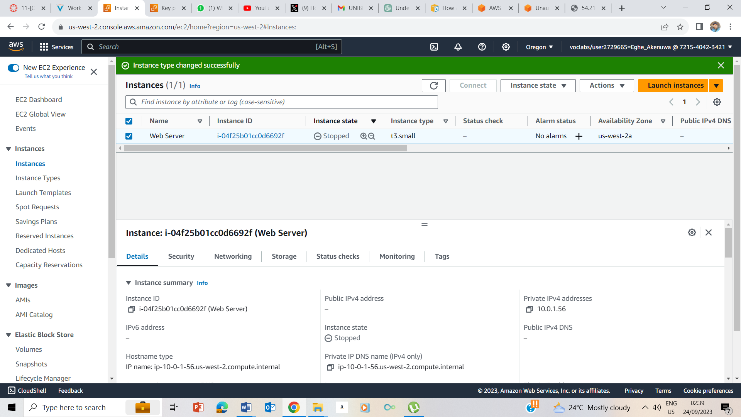

I clicked on Instance and checked the box next to web server

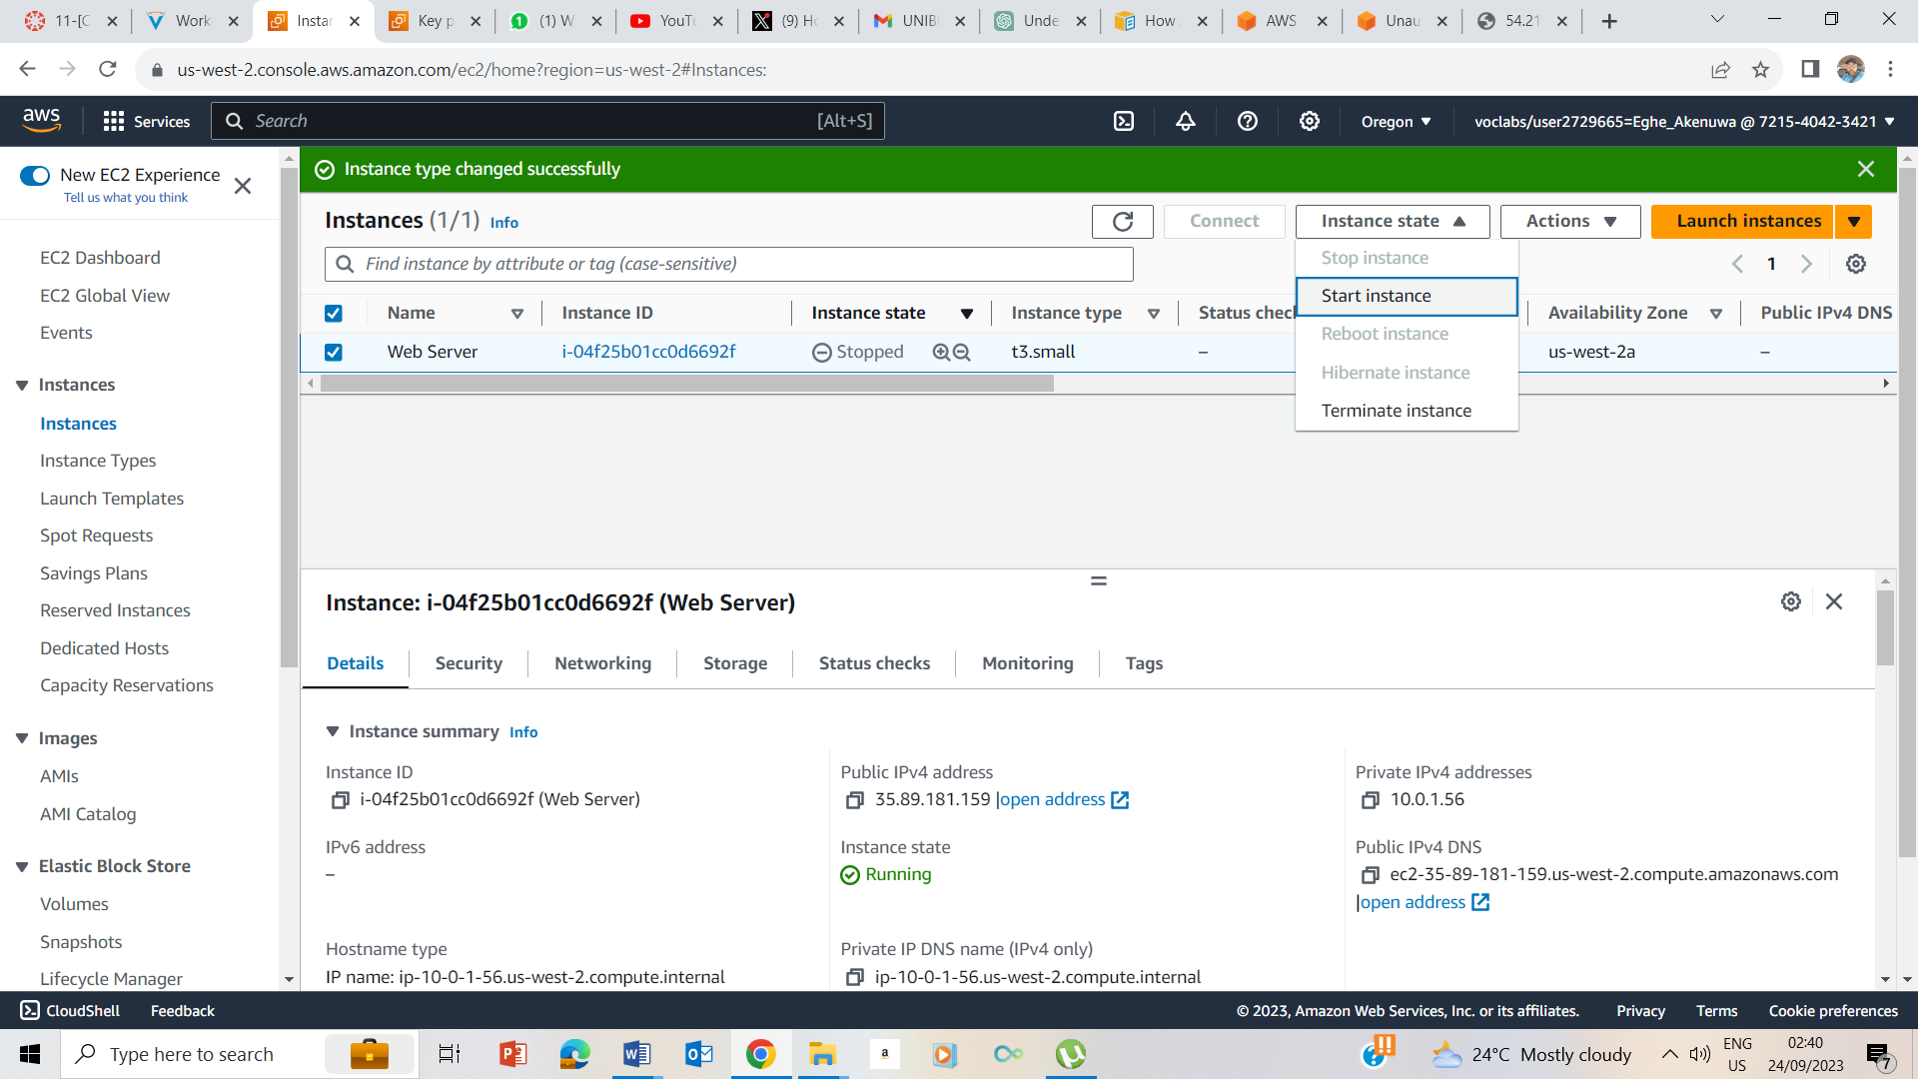

I clicked on the instance state drop down and selected Start Instance

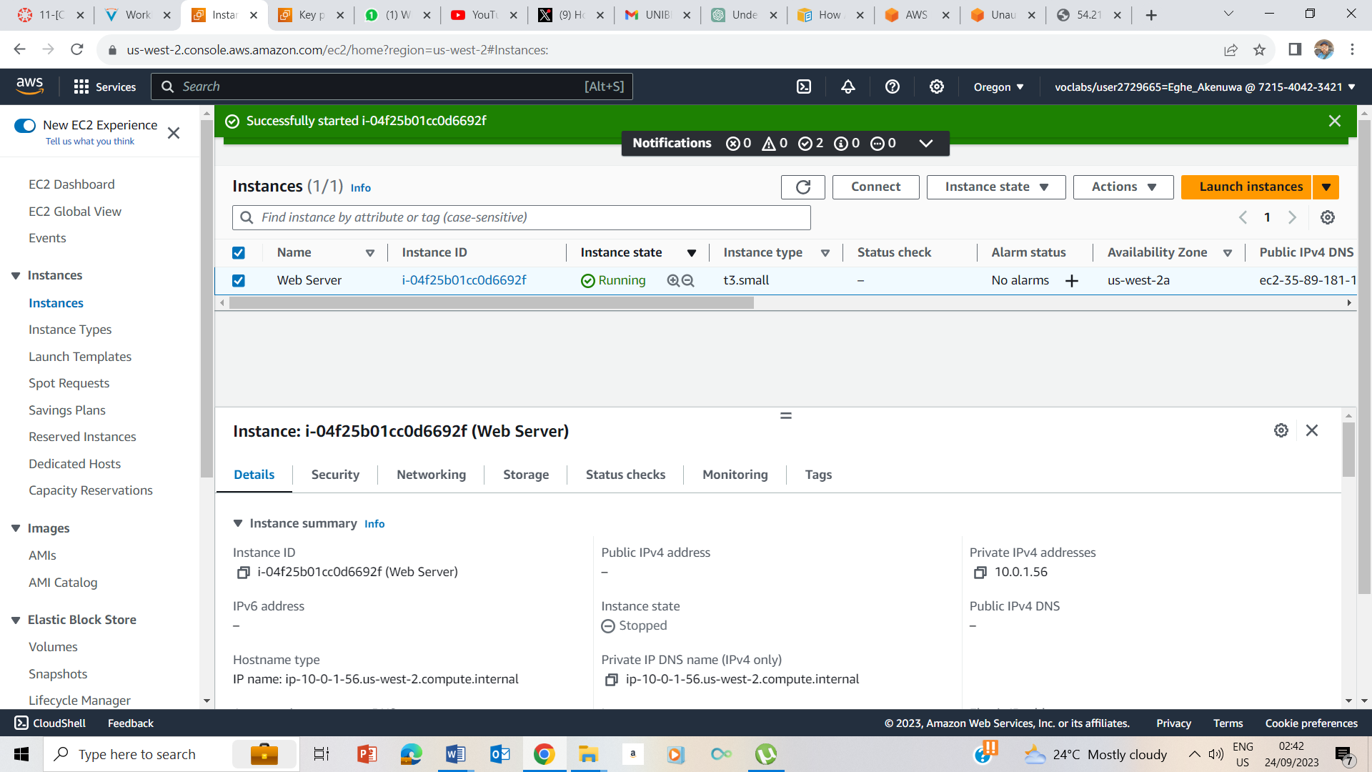

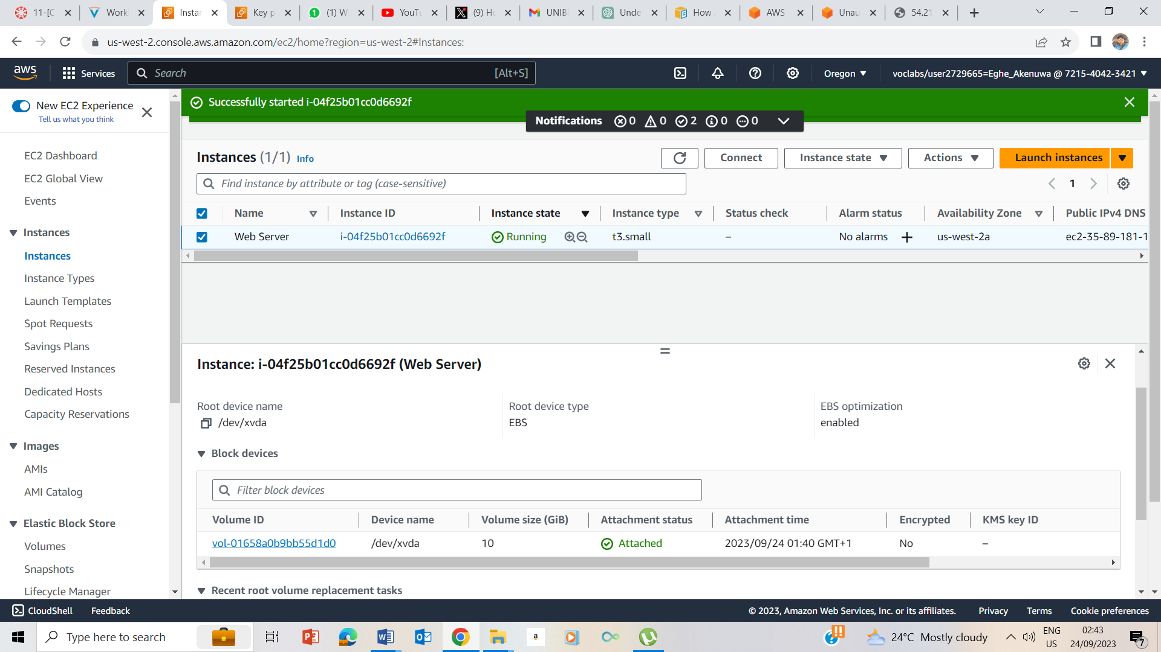

At the end it is confirmed that the instance type has been changed to t3.small from t3.micro and the volume has changed to 10GiB from 8GiB.

## Task 5: Test Termination Protection

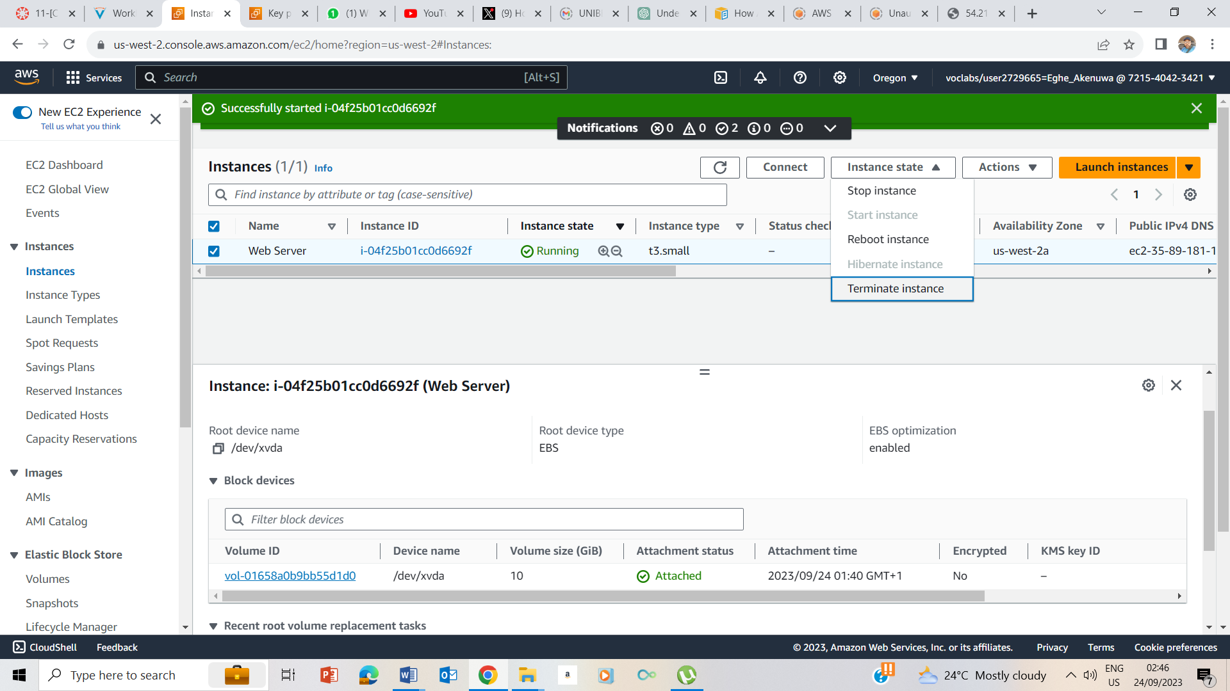

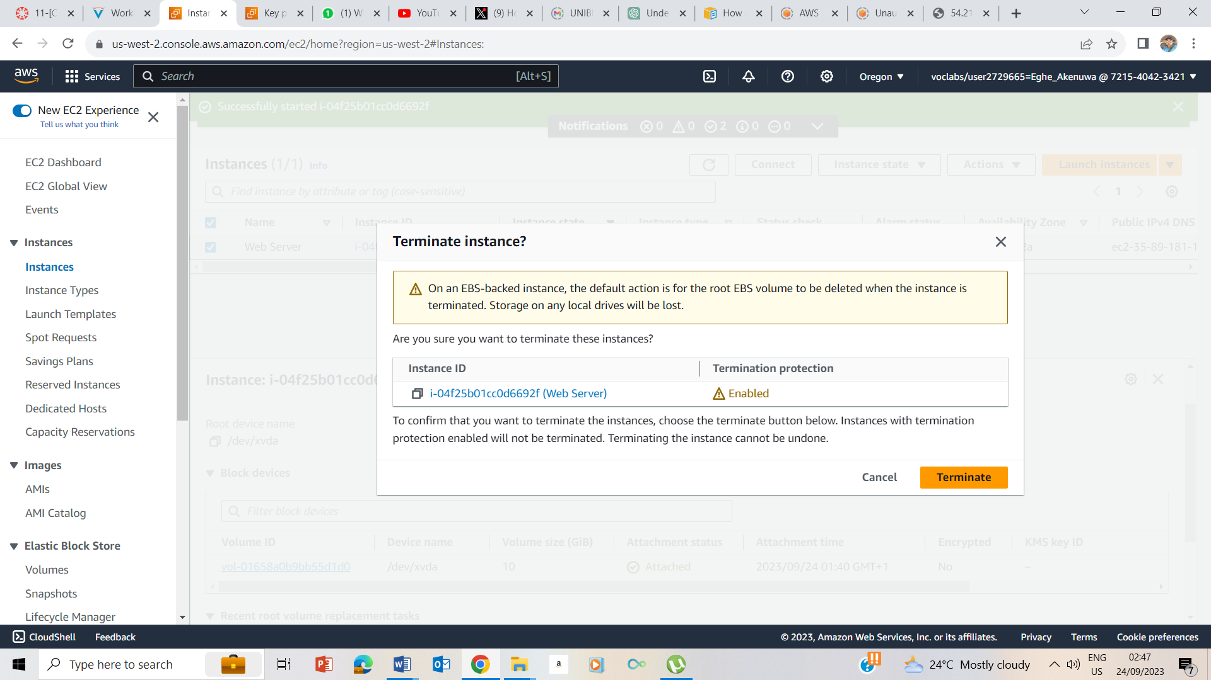

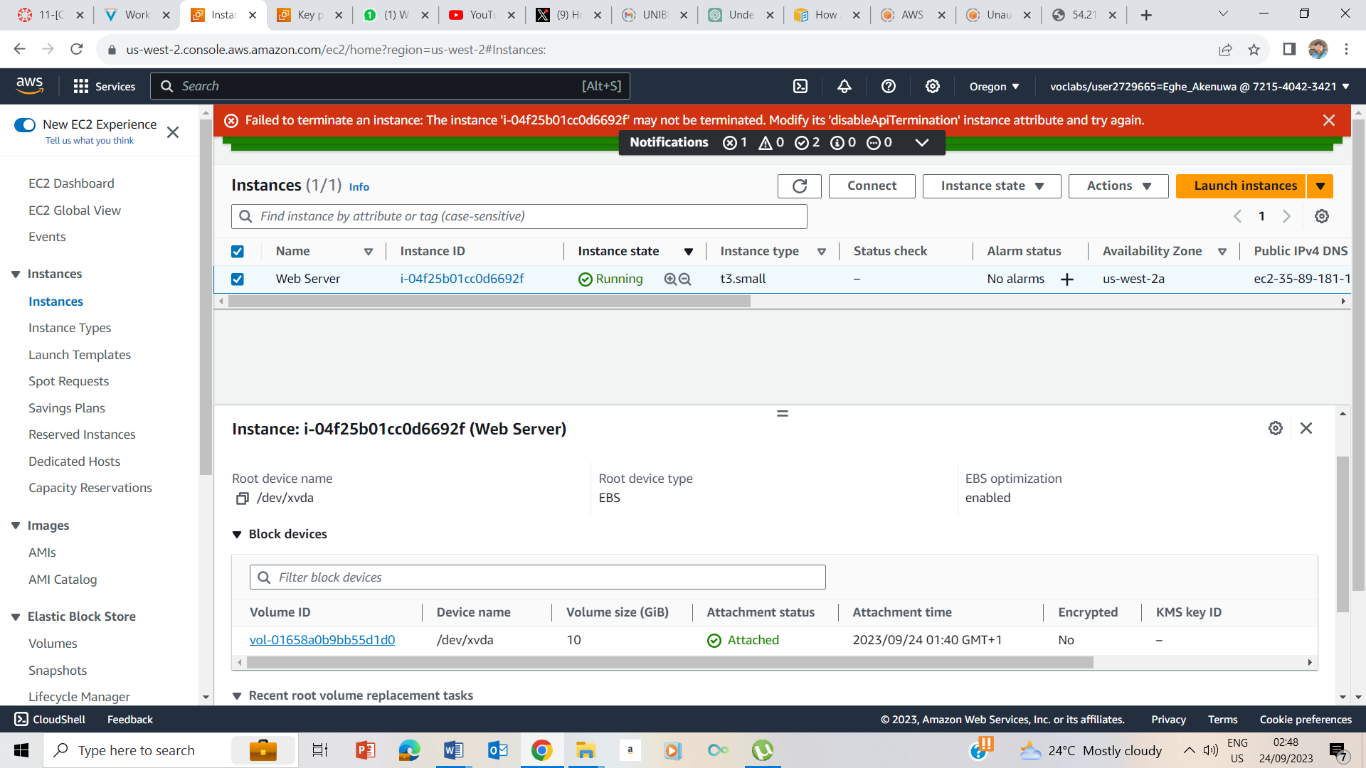

Tried to Terminate Instance, but Couldn’t because Terminate Instance is Protected.

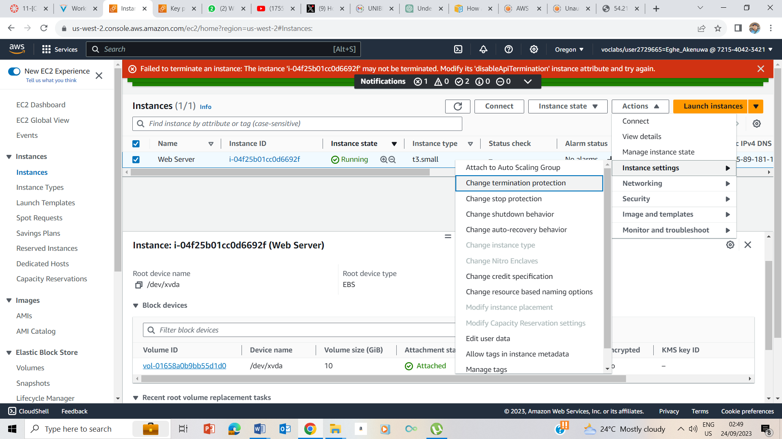

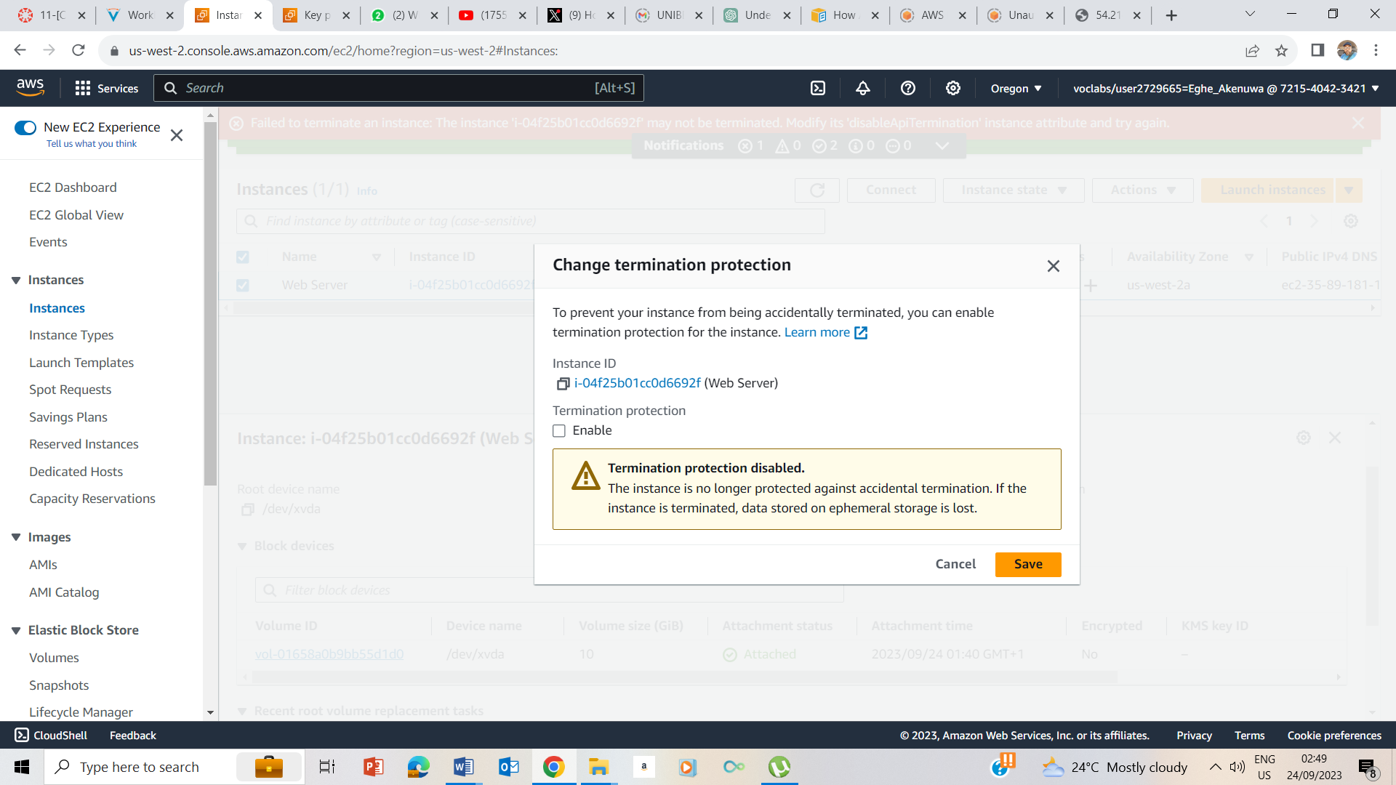

I changed the termination protection settings by unchecking the enable box and saving.

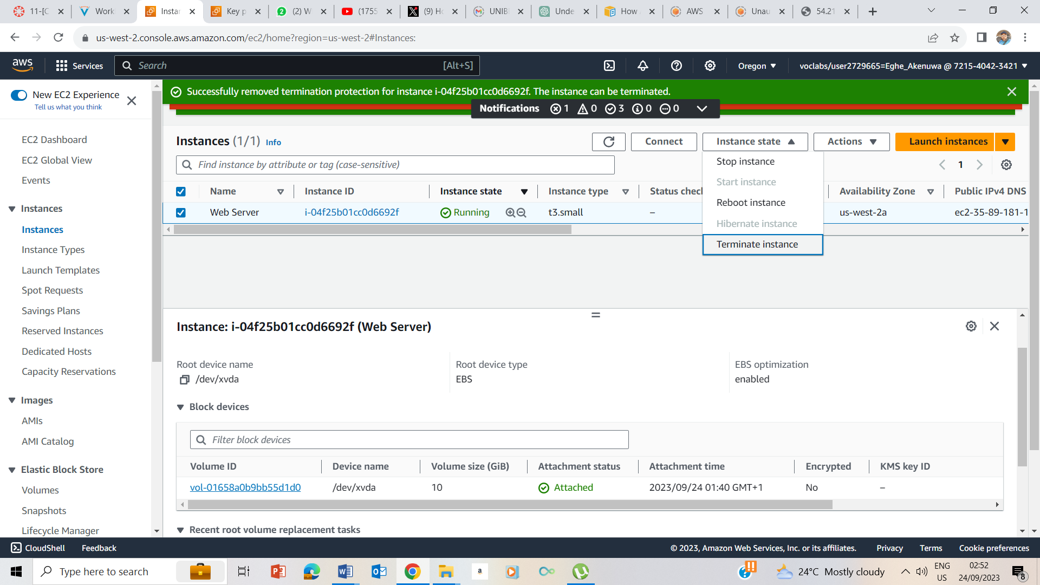

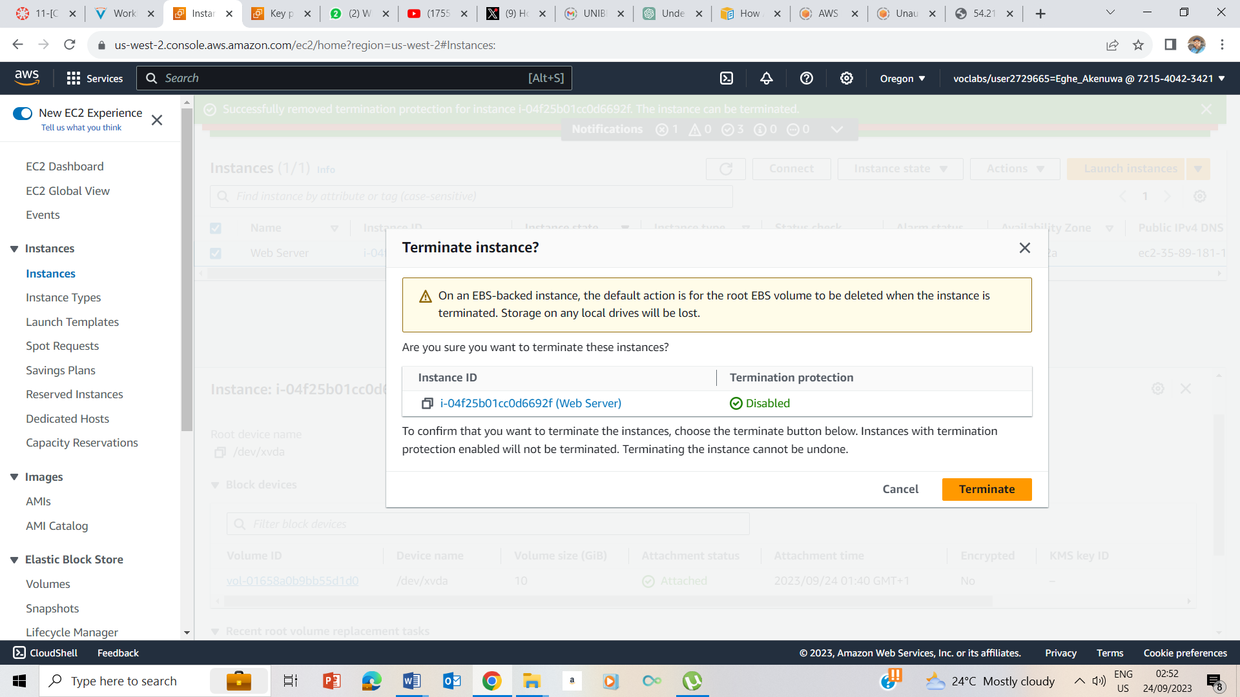

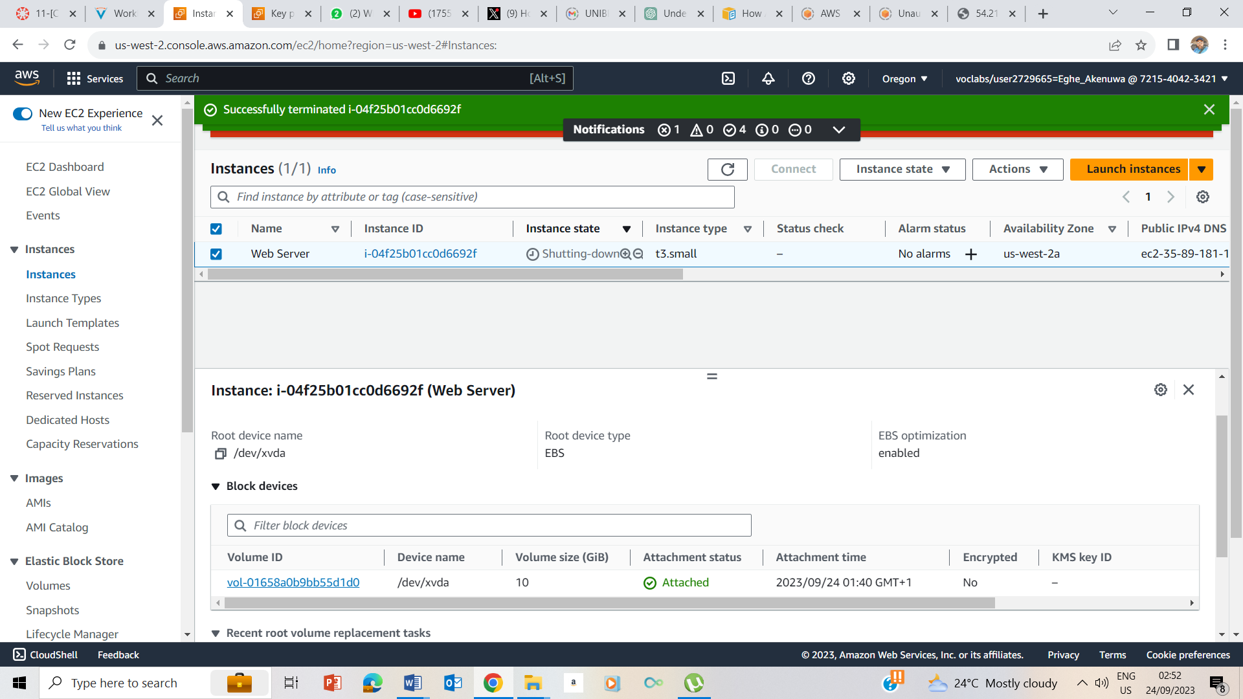

Instance is Successfully Terminated.

## Lab Complete

